<https://www.youtube.com/watch?v=5Z9OIYA8He8&list=PLblh5JKOoLUIzaEkCLIUxQFjPIlapw8nU&index=9>

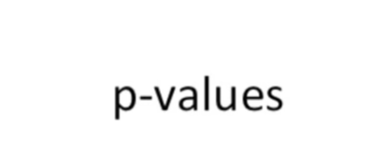

Hello and welcome to star quest.

Stat quest is brought to you by the friendly folks in the genetics department at the University of North Carolina at Chapel Hill.

Today we're going to talk about p-values.

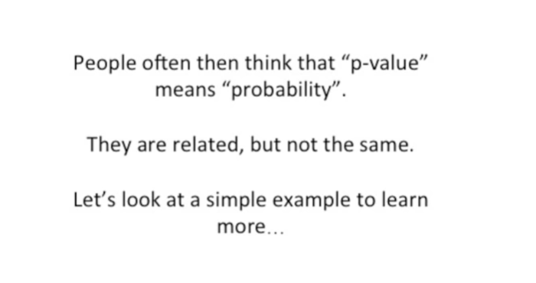

People often think that p-value means probability they are related but not the same.

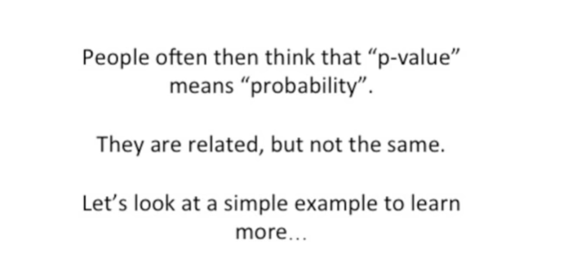

Let's look at a simple example to learn more.



Our simple example is just going to be flipping a coin two times.

That's about as simple as it gets.

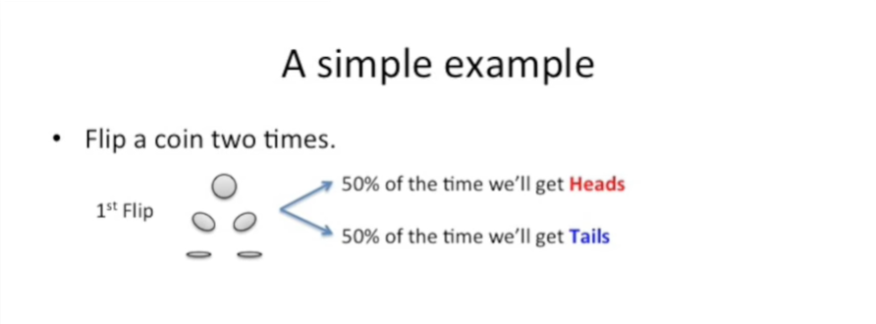

The first time we flip the coin 50% of the time we'll get heads and 50% of the time we'll get tails.

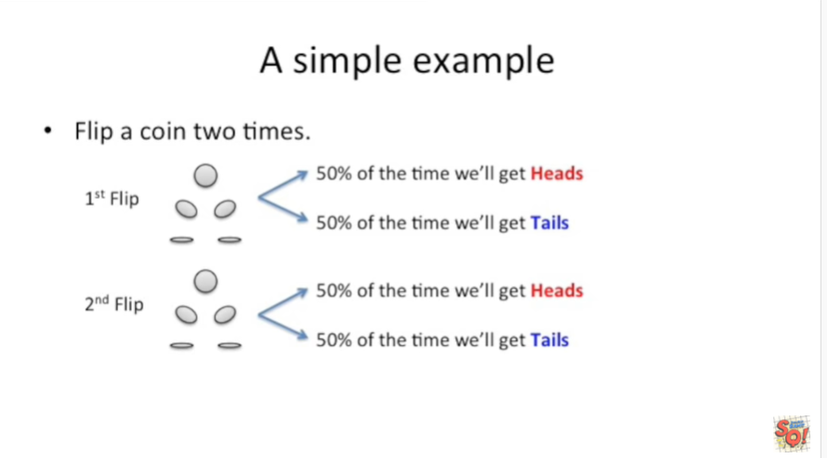

And the second time we flip the coin again 50% of the time we'll get heads and 50% of the time we'll get tails.

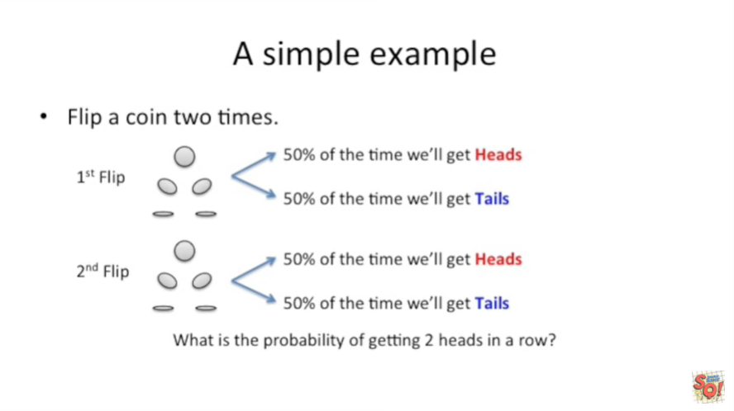

What's the probability of getting two heads in a row ?

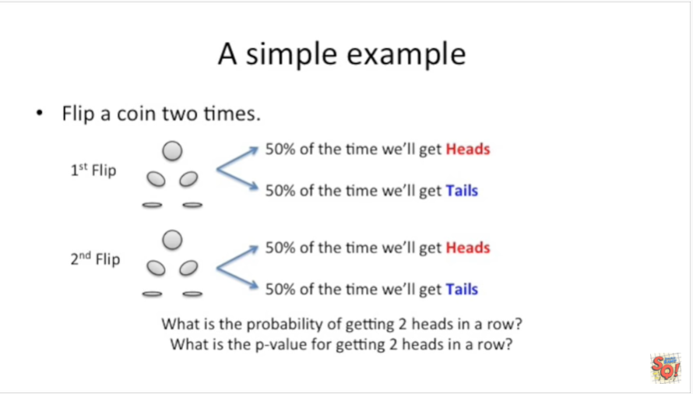

And what's the p-value for getting two heads in a row ?

We're going to answer both of those questions real soon.



Let's start with the first one what's the probability of getting two heads in a row.

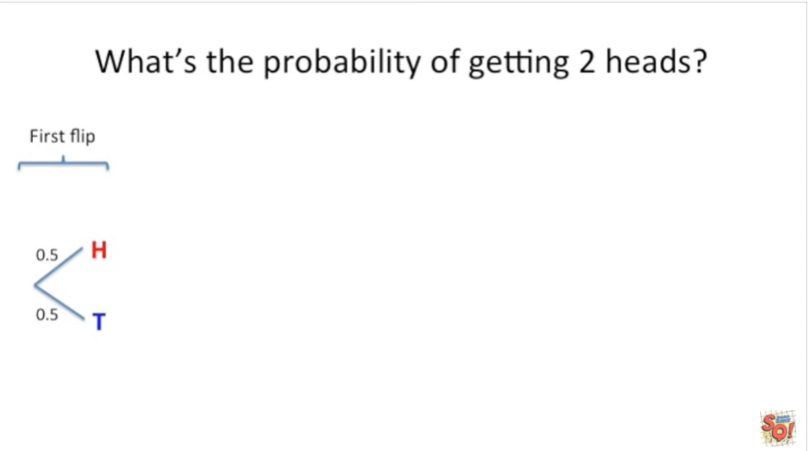

Like we just said the first flip will give us heads 50% of the time and tails 50% of the time.

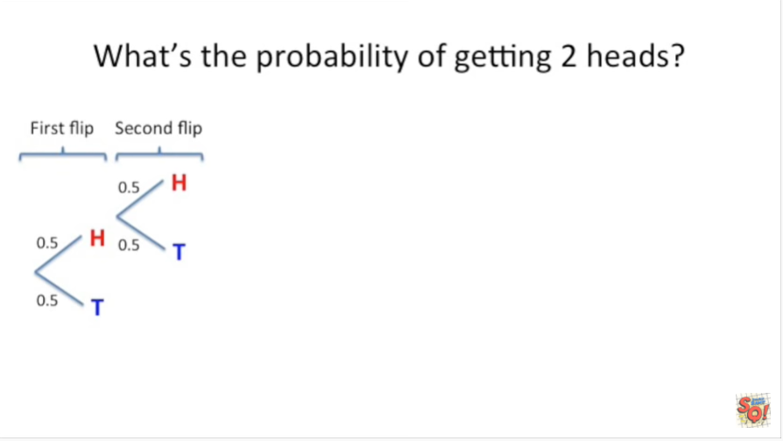

If we get heads the first time we flip the coin and then we flip the coin again there's a 50% chance we'll get heads and a 50% chance we'll get tails.

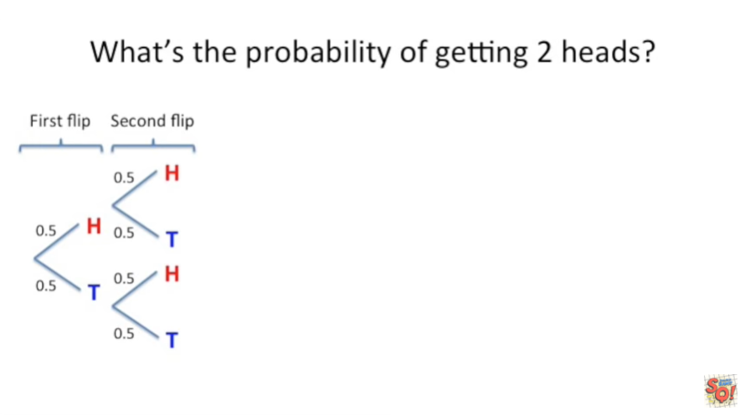

If we get tails the first time we flip a coin the second time we flip a coin we still have a 50% chance of getting heads and a 50% chance of getting tails.

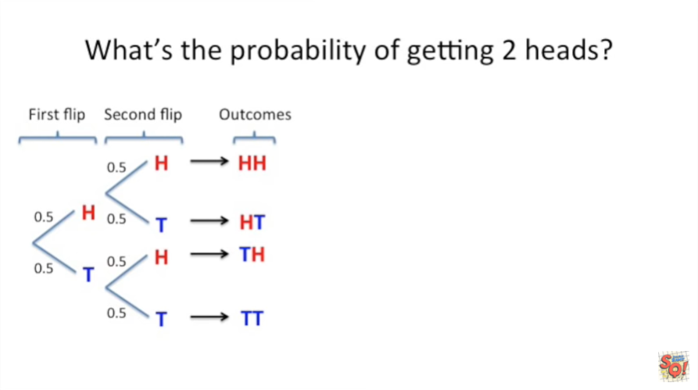

After flipping a coin twice we have four possible outcomes.

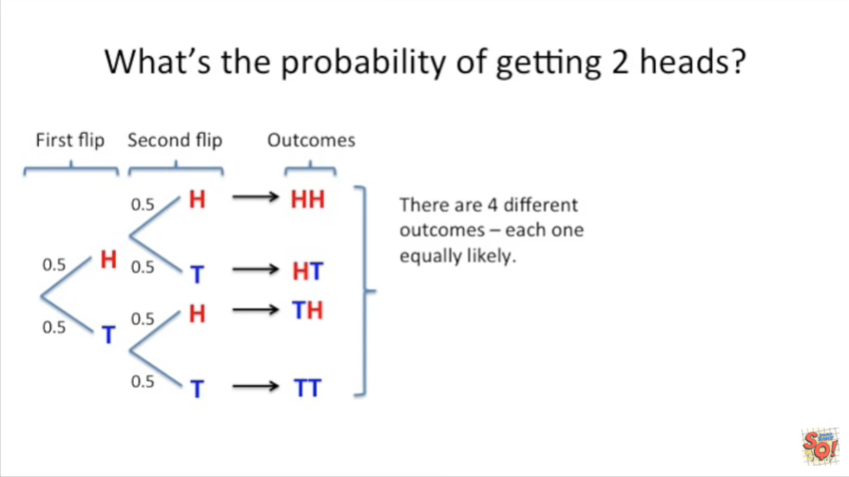

In this case each outcome is equally likely.

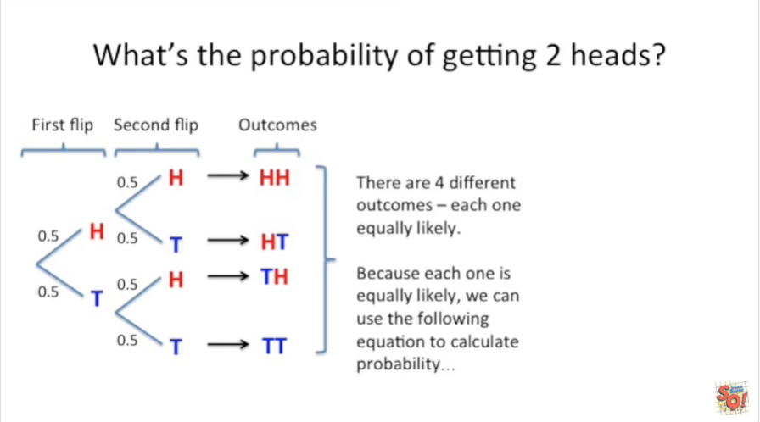

Because each one is equally likely we can use the following equation to calculate probability.

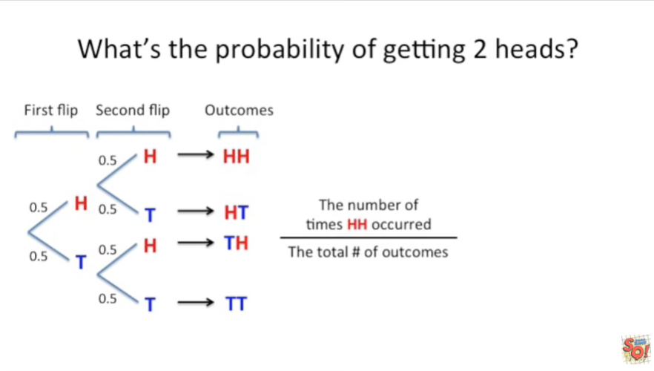

We take the number of times two heads occurred divided by the total number of outcomes.

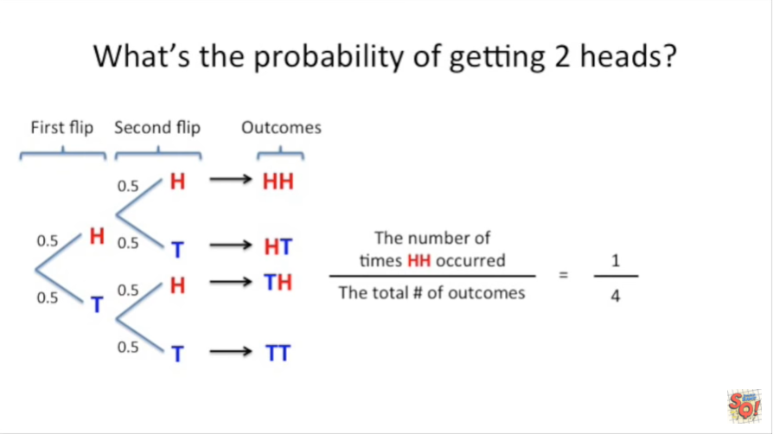

Of the four outcomes two heads in a row only occurred once.

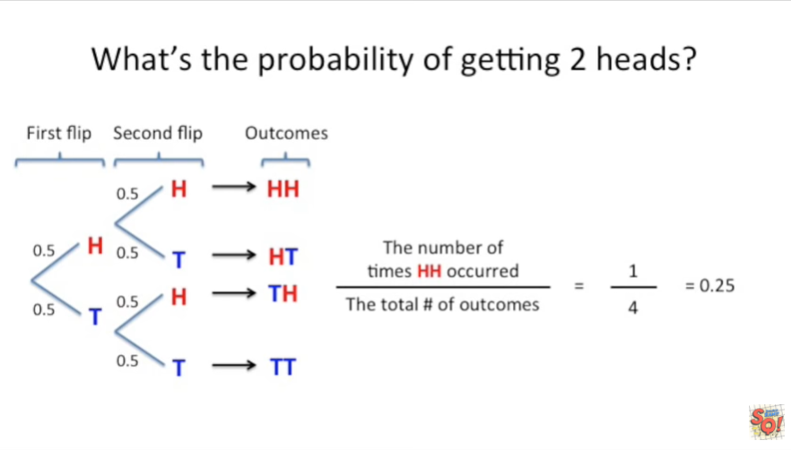

Doing the math gives us the probability of getting two heads in a row in this case it's 0.25.

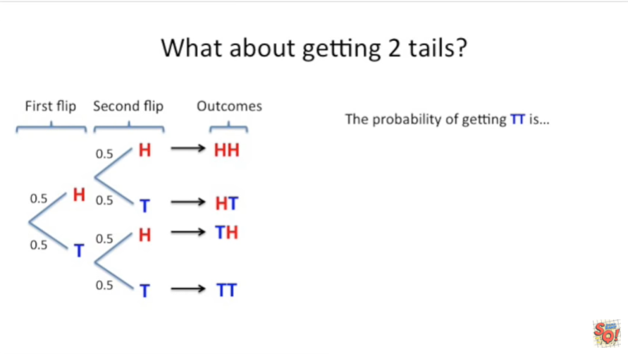

What if we got two tails in a row.

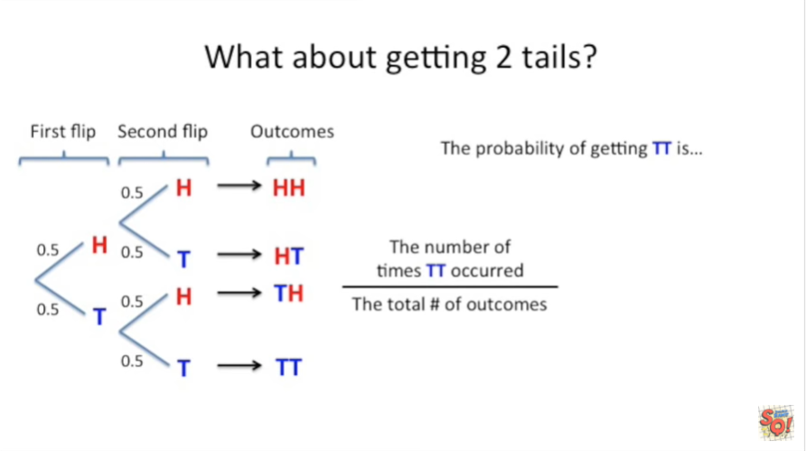

The probability of getting two tails is just like before.

The number of times two tails occurred in the outcomes divided by the total number of outcomes.

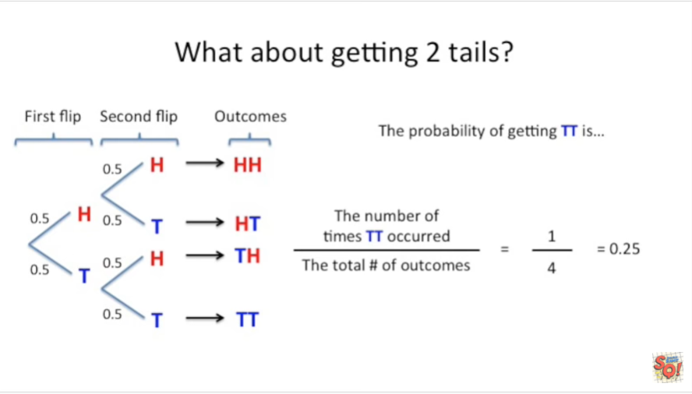

This gives us 1/4 or 0.25 the exact same probability we got for two heads in a row.

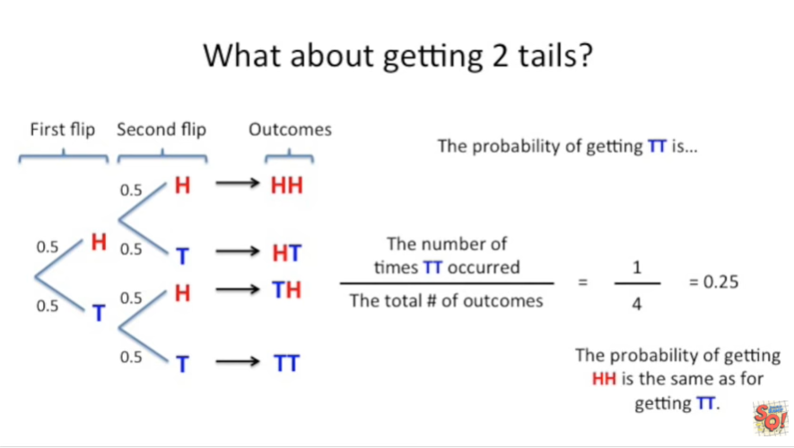

That's kind of a no-brainer but this will come in handy in a few more slides to just bear with me.

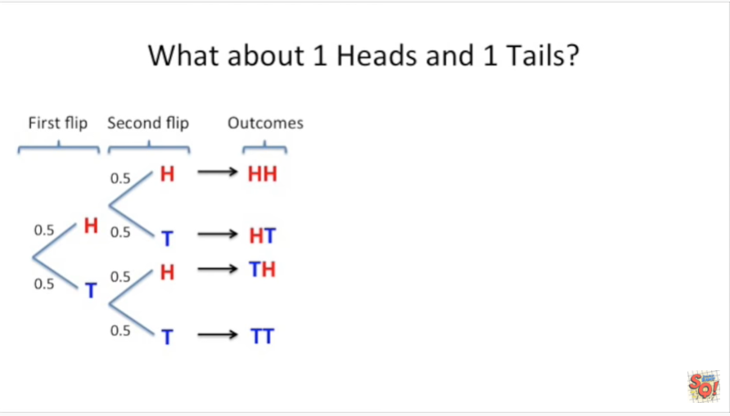

What about getting onTe heads and one tails and don't you think it's a little funny that in English we say one heads we're heads is plural weird.

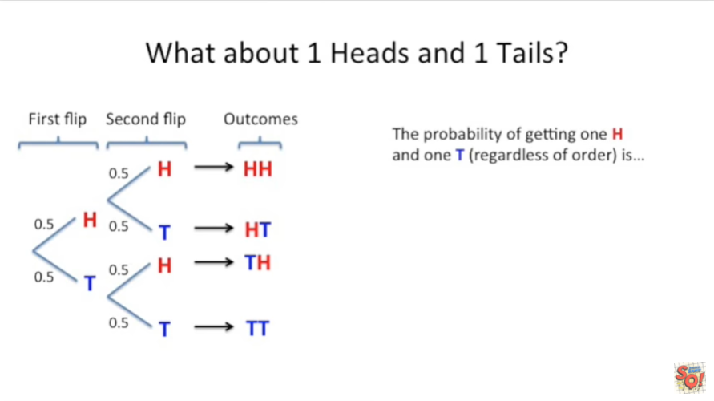

The probability of getting one heads and one tails regardless of order is

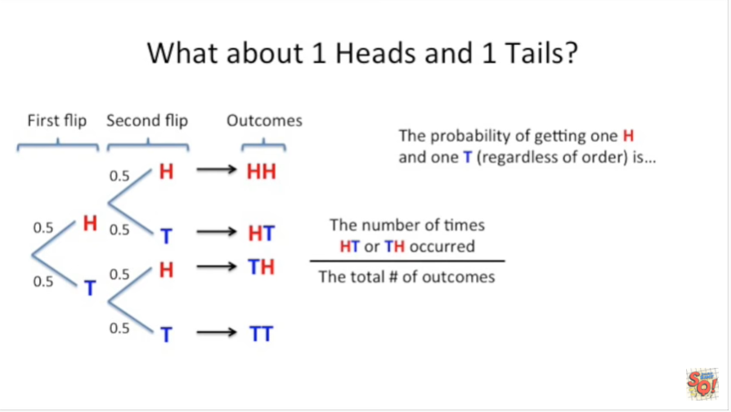

the number of times H and T or T and H occurred divided by the total number of outcomes.

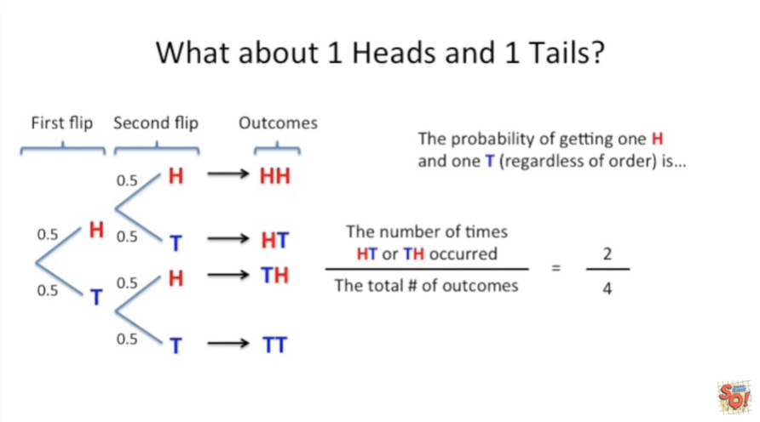

In this case we got one HT + 1 th so that's 2/4.

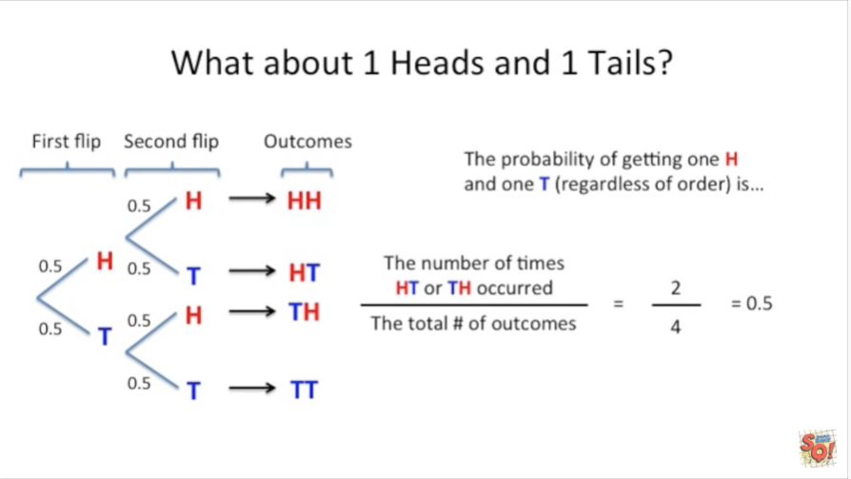

In the probability of getting one heads and one tails is 0.5.

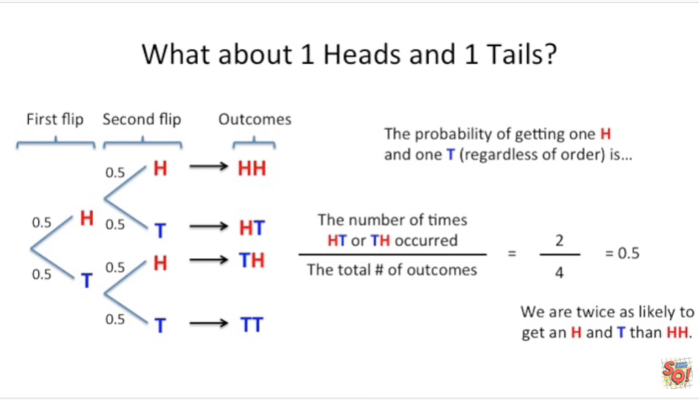

Thus we are twice as likely to get a heads and a tails than we are to get two heads in a row.

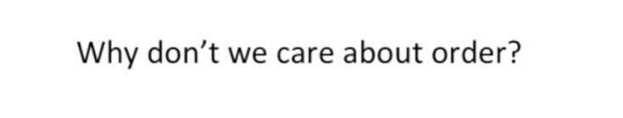

Why don't we care about the order ?

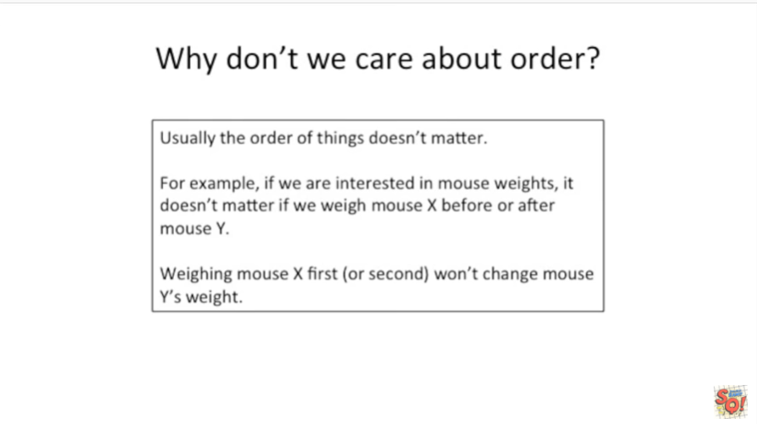

Usually the order of things doesn't matter.

For example if we are interested in Mouse weights, it doesn't matter if we weigh Mouse X before or after Mouse Y. Weighing mouse X first or second won't change mouse Y’s weight.

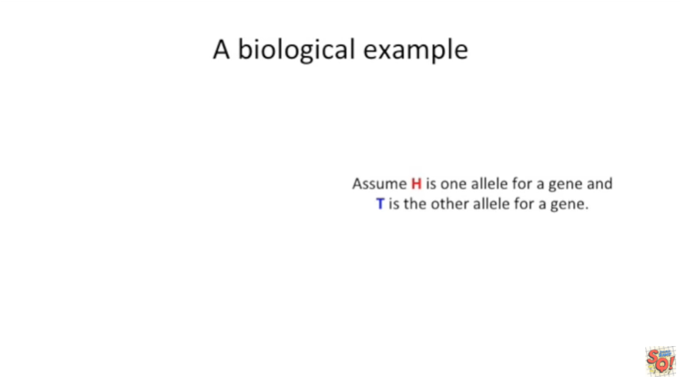

Here's a biological example.

Instead of H meaning heads assume H is one allele for a gene and T is the other allele for a gene.

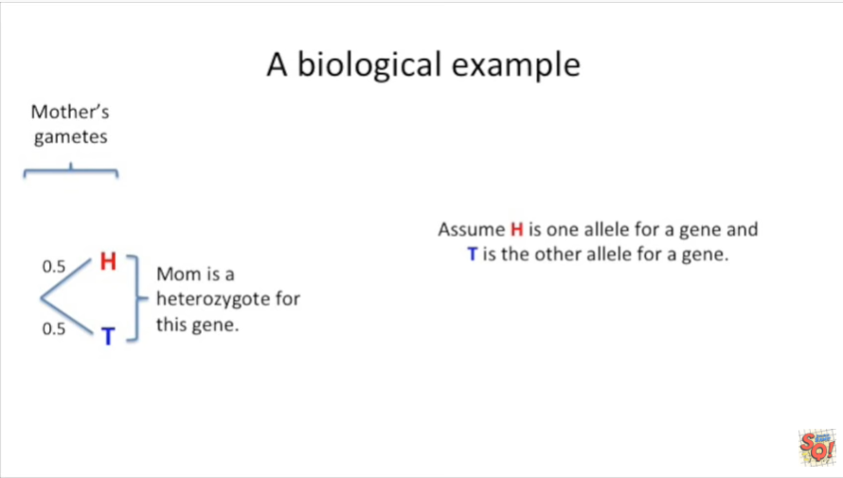

If the mother is a heterozygote and has both alleles for the gene then 50% of our gametes will have the H allele and the other 50% of our gametes will have the T allele.

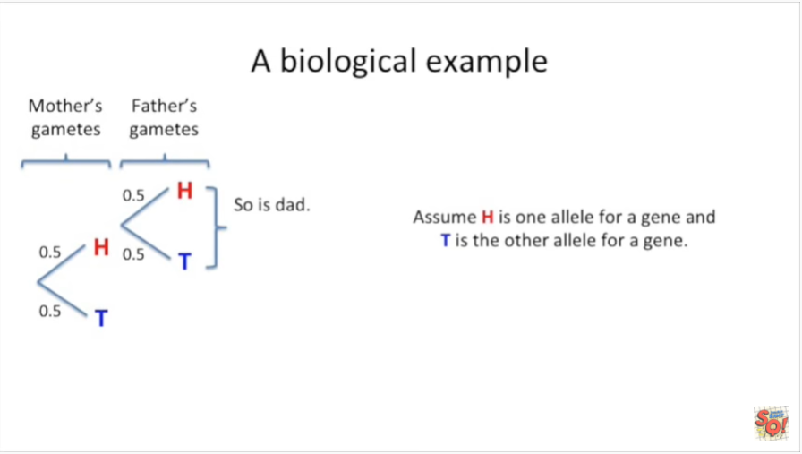

Similarly if dad is also a heterozygote for the gene then 50% of his gametes will have the H allele and 50% of his gametes will have the T allele.

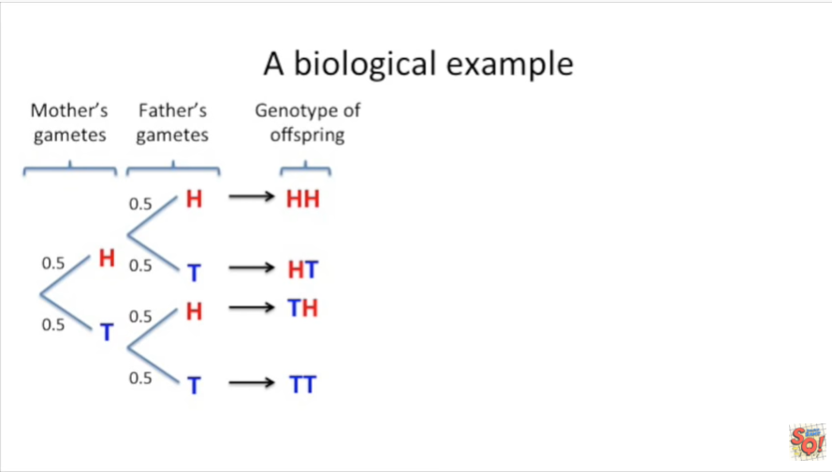

Knowing what the gametes are we can figure out the possible genotypes for the offspring.

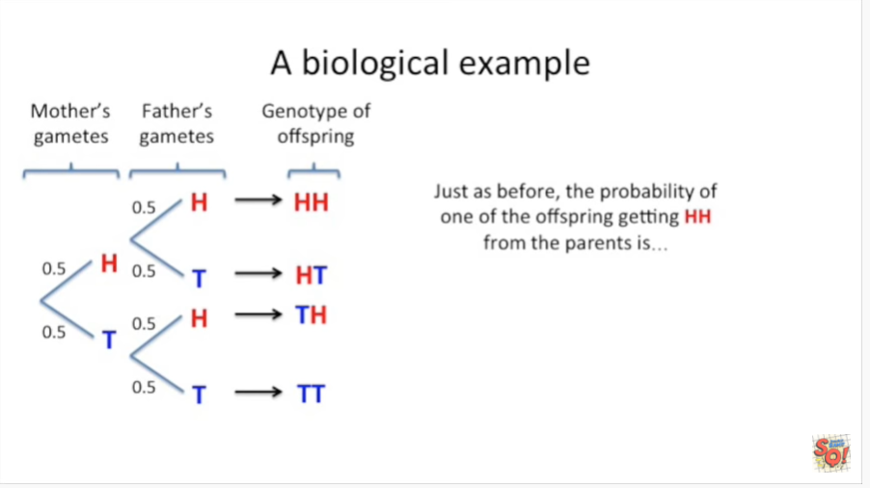

Just as before the probability of one of the offspring getting to H alleles from apparents is

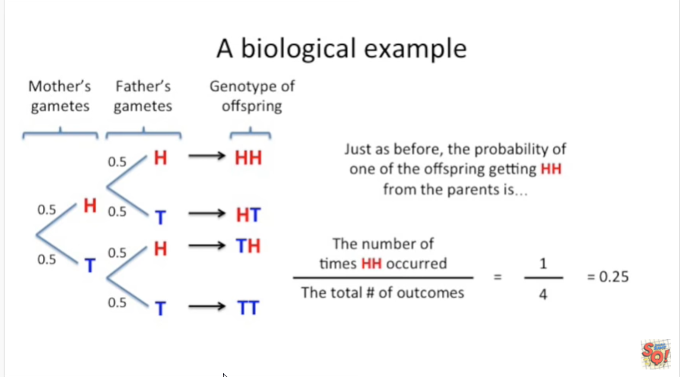

the number of times h h occurred in the list of possible genotypes of the offspring divided by the total number of outcomes.

In this case that means 1/4 or 0.25.

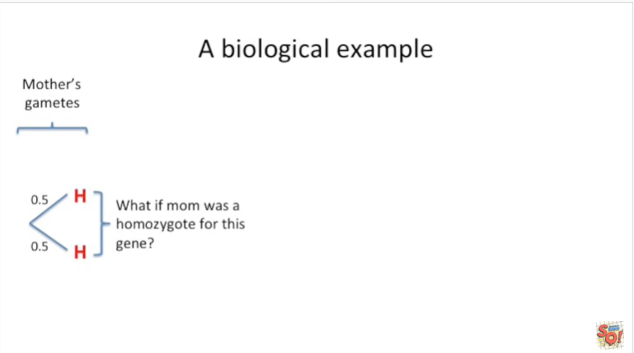

What if mom was a homozygote for this gene that means she has two H alleles.

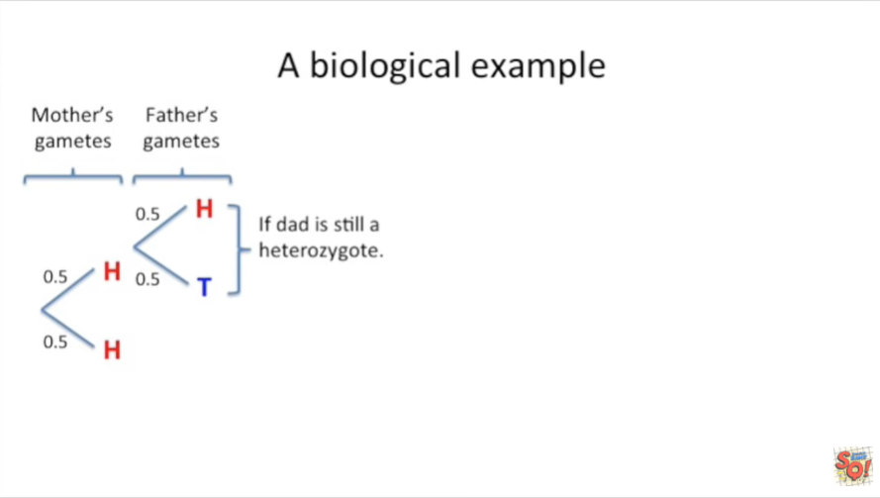

If dad was still a heterozygote then our list of possible genotypes for the offspring would be slightly different than before.

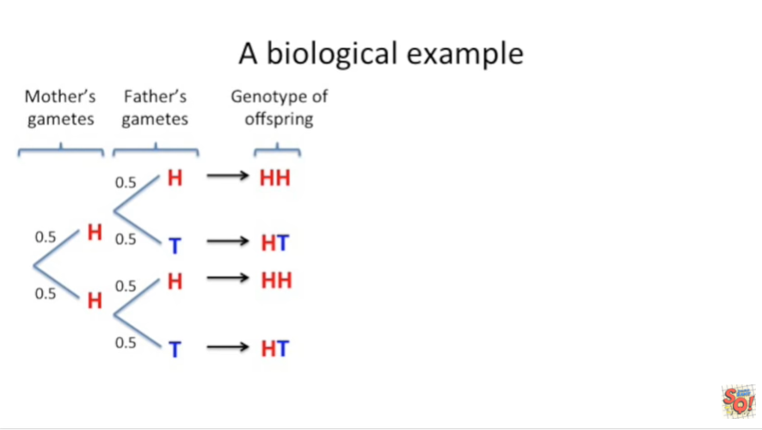

This time H H occurs twice in the list of possible outcomes.

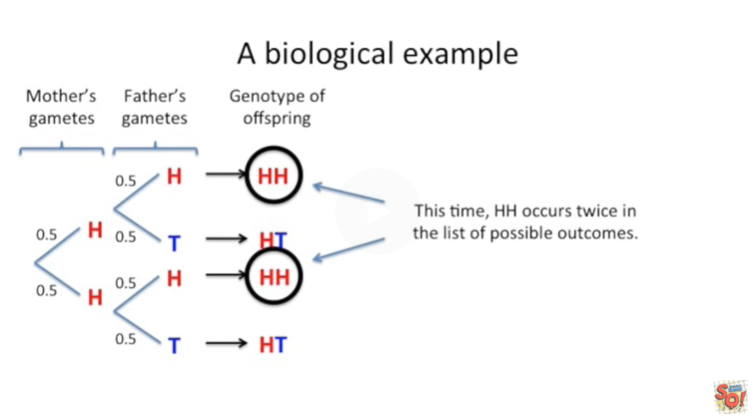

Thus the probability of one of the offspring getting H H from a parent's is just as before the same formula.

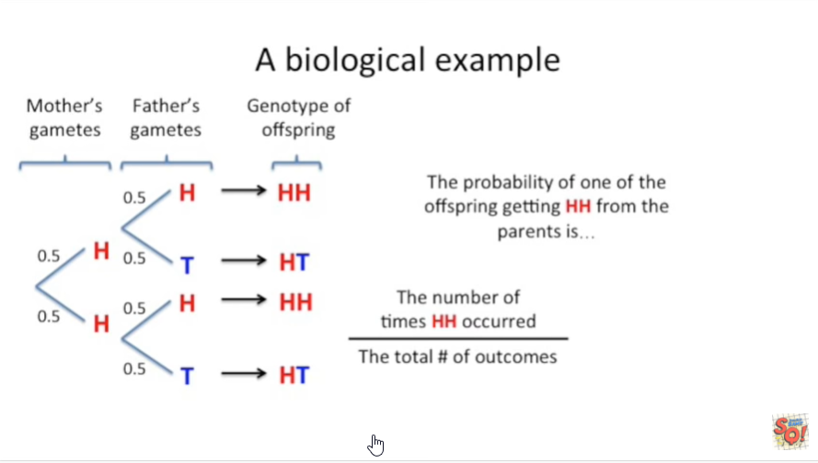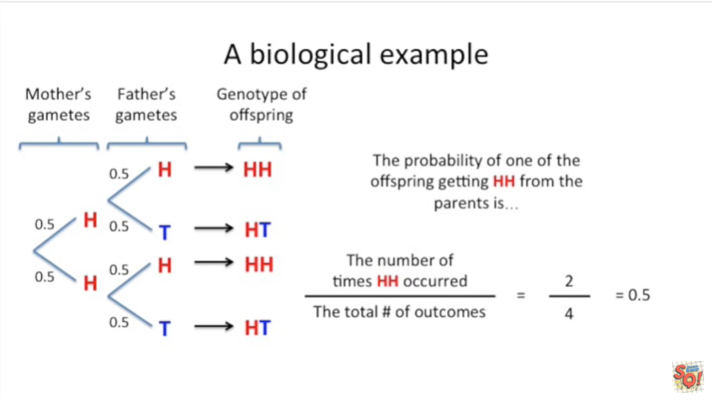

But now we have two in the numerator and the probability is 0.5

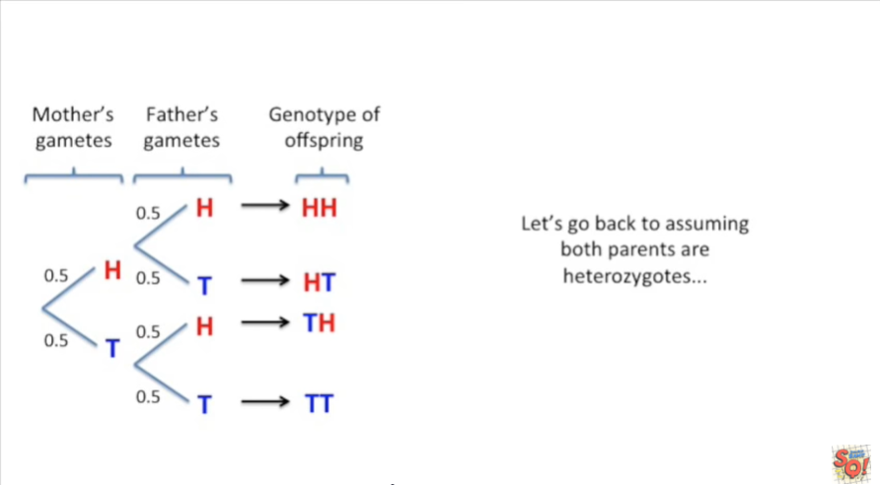

Let's go back to assuming both parents or heterozygotes or if this genetics goon babel doesn't mean anything to you you can imagine we're flipping a coin again.



We've solved for the probability for getting H H.

Now let's solve for the p-value.

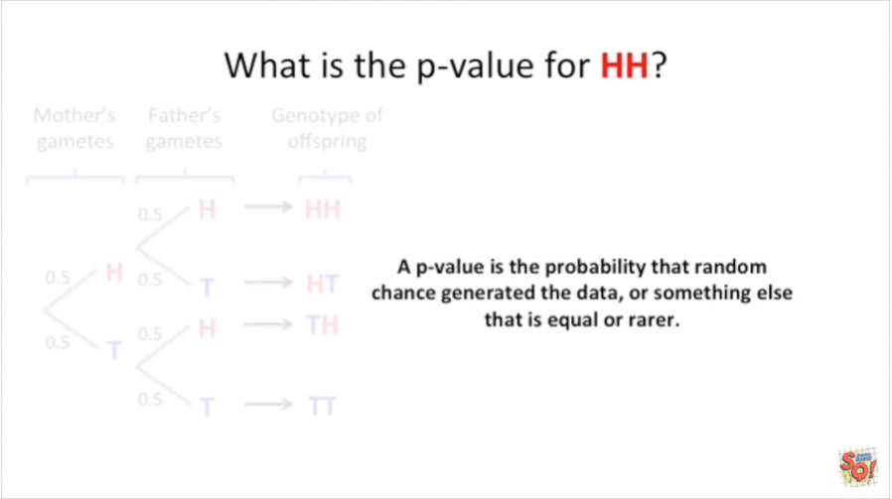

A p-value is the probability that random chance generated the data or something else that is equal or rarer.

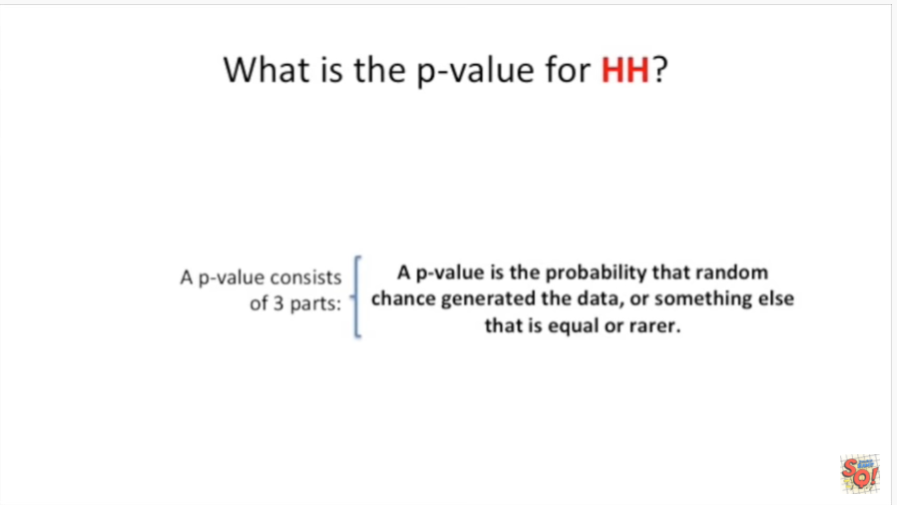

A p-value consists of three parts.

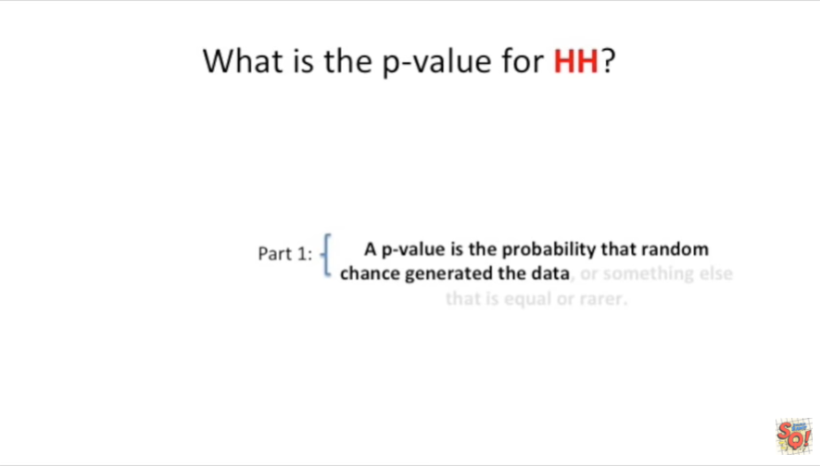

The first part is the probability that random chance generated the data that you observed.

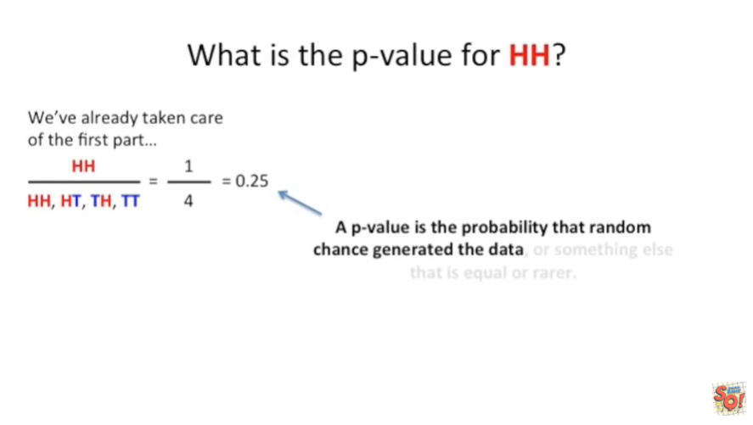

We've already taken care of this first part we've worked out the probability for getting two heads or two H alleles.

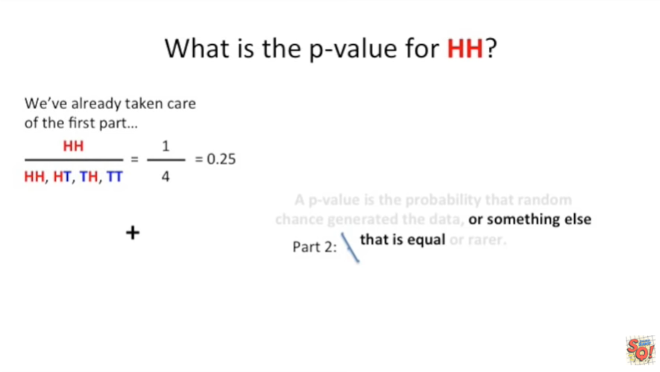

The second part of a p-value is to add anything else in the outcomes that has equal probability.

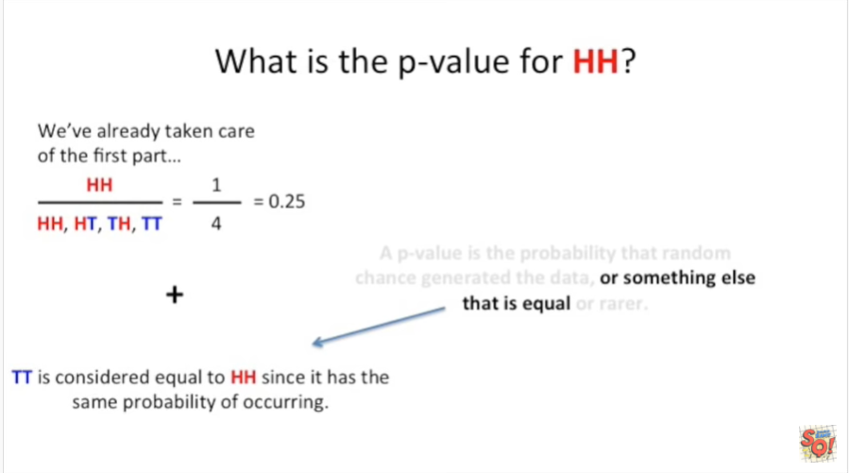

That is to say getting two T's is considered equal to getting two H's since it has the same probability of occurring.

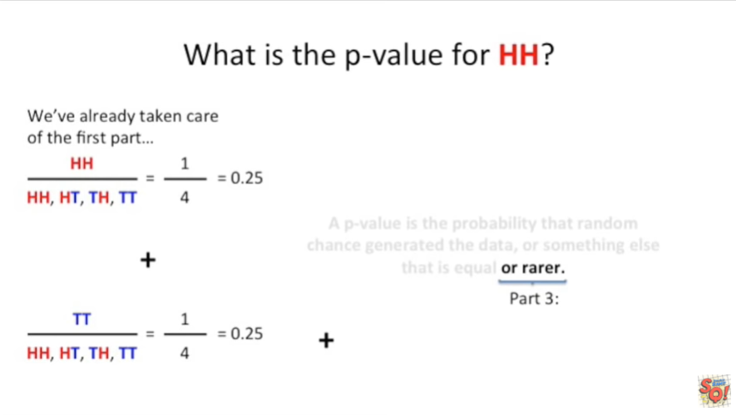

We already worked out that probability as well.

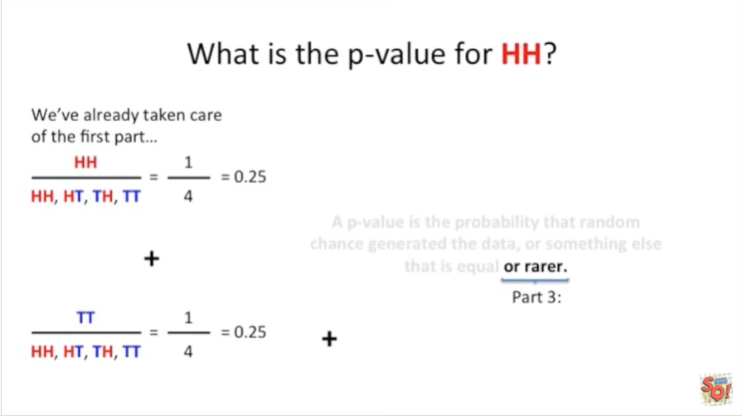

The last part of a p-value is to add on anything that's even rarer than what you observed.

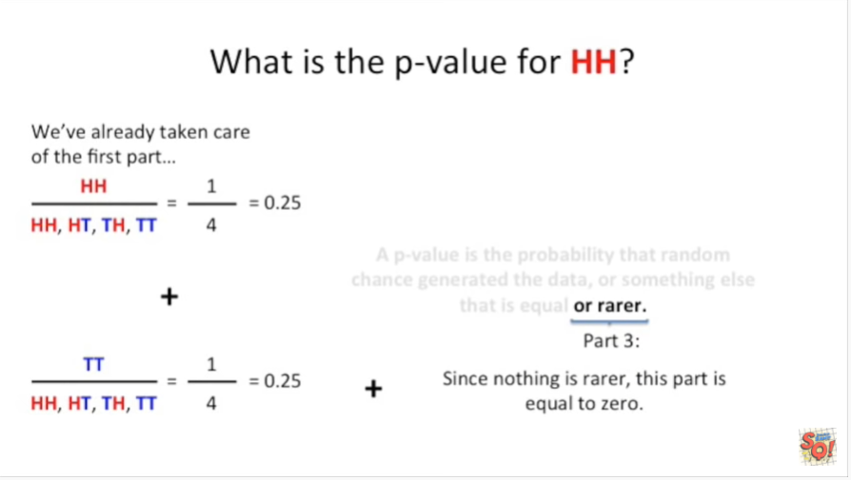

Since there are no outcomes that are rarer than getting h h this part is equal to zero.

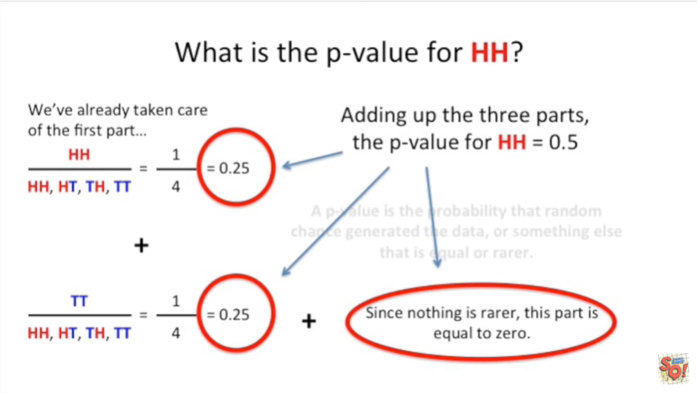

Adding up the three parts the p-value for h h is 0.5.



To summarize this example :

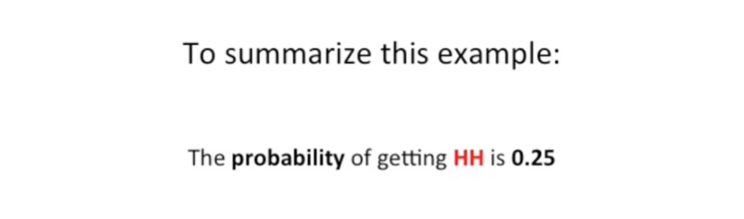

the probability of getting h h is 0.25

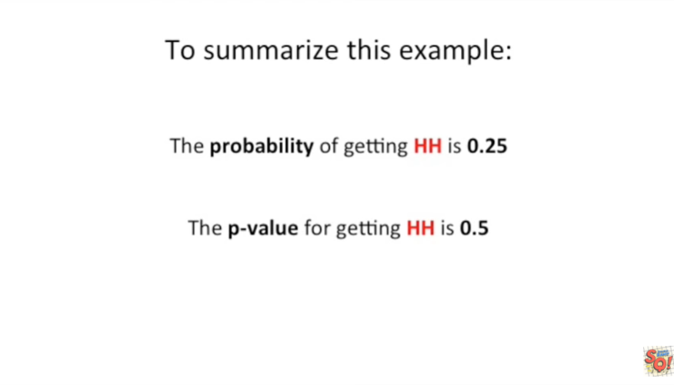

the p-value for getting h h is 0.5.

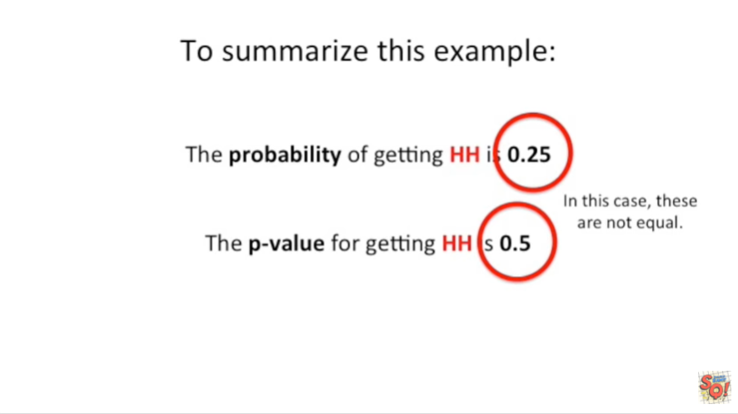

In this case these two values are not equal.



Okay so now that we've looked at a simple example.

Let's move on to a slightly more complex example.



Now we're going to flip the coin five times and if we get heads each time what's the probability of that.

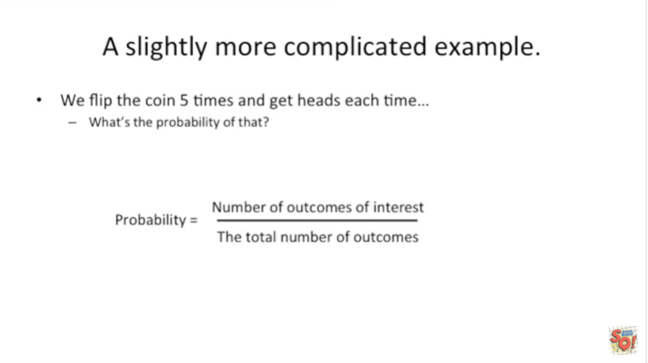

Well as we saw before the probability is the number of outcomes of interest divided by the total number of outcomes.

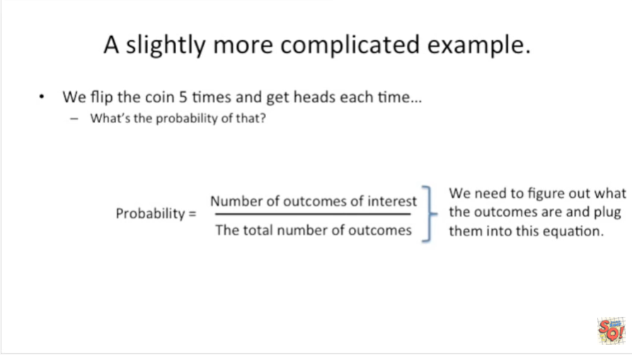

We need to figure out what the outcomes are and then plug them into this equation.

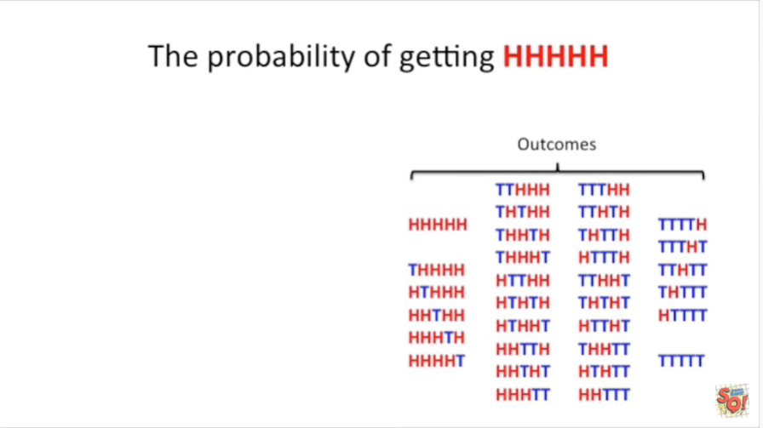

Here I've listed all the outcomes of flipping a coin five times in a row.

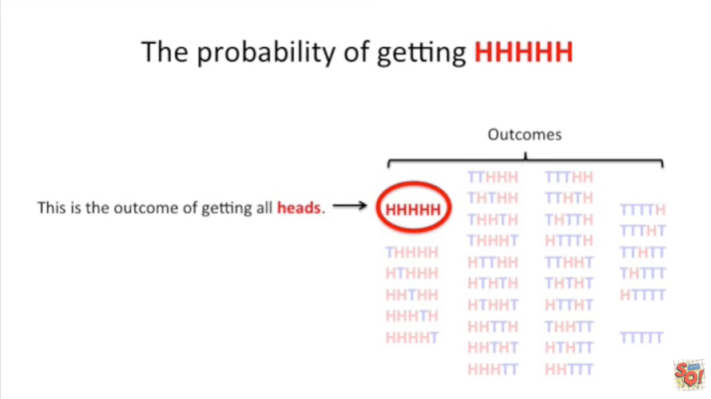

This is the outcome of getting all heads.

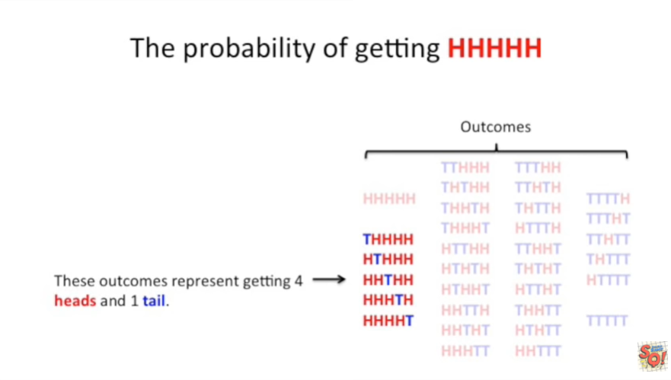

These outcomes represent getting four heads and one tail.

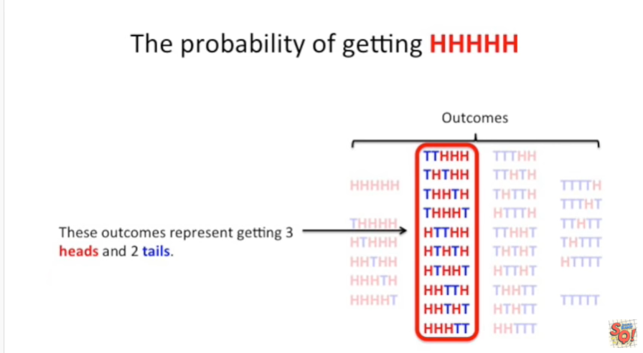

These outcomes represent getting three heads and two tails.

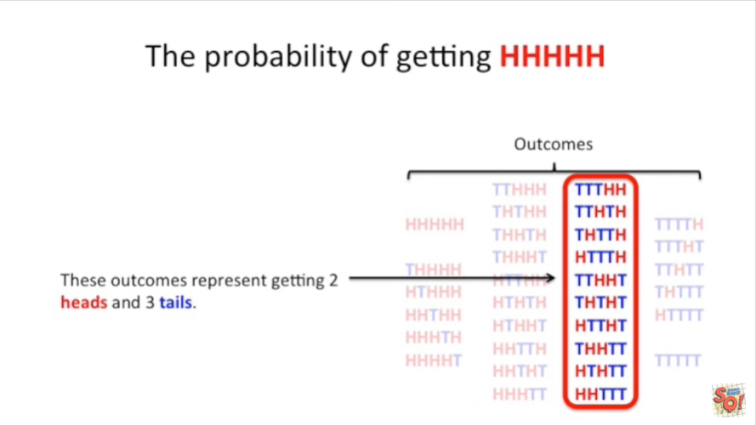

These outcomes represent getting two heads and three tails.

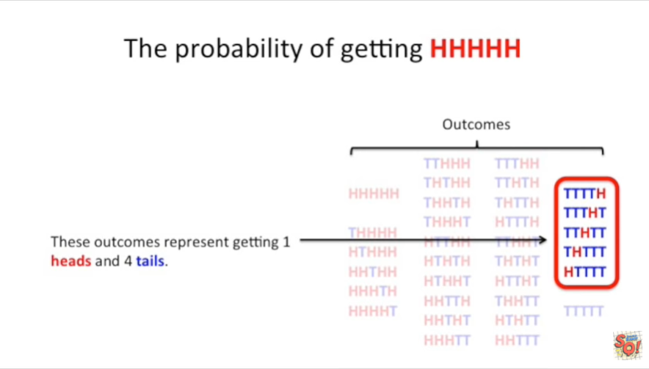

These outcomes represent getting one heads and four tails.

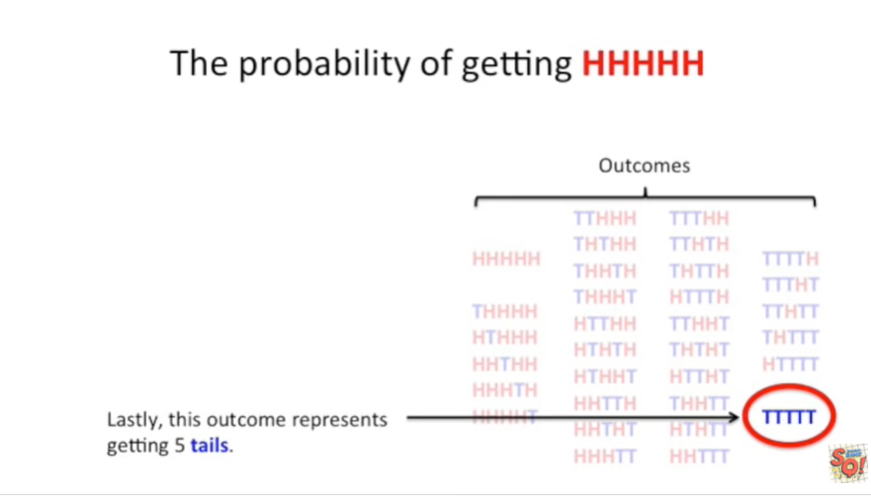

Lastly this outcome represents getting five tails.

Whew that's a lot of outcomes.

Thirty-two in total.

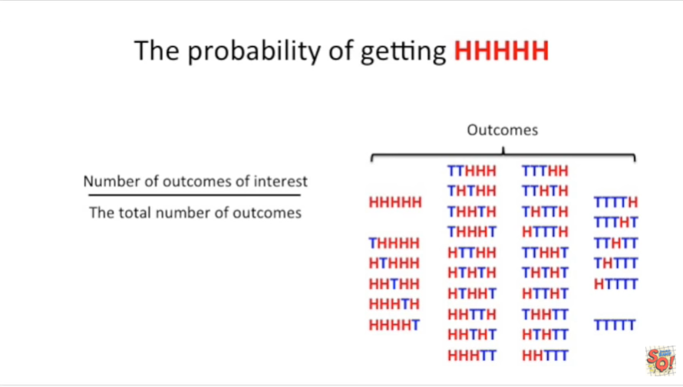

Here's our equation for calculating probability.

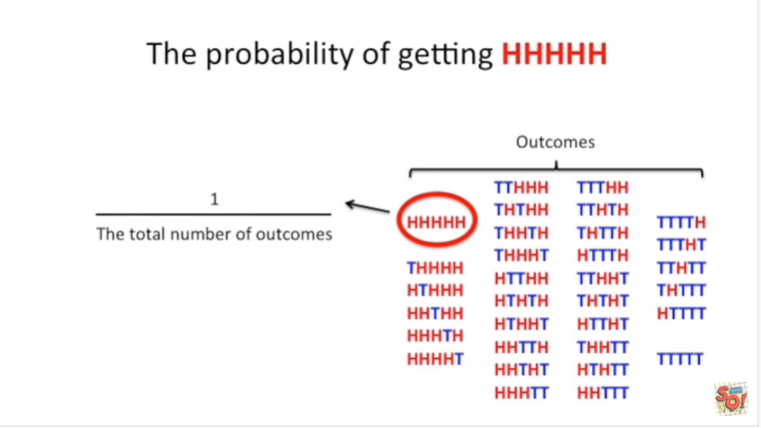

And since there is only one occurrence of five H's in a row we put one in the numerator.

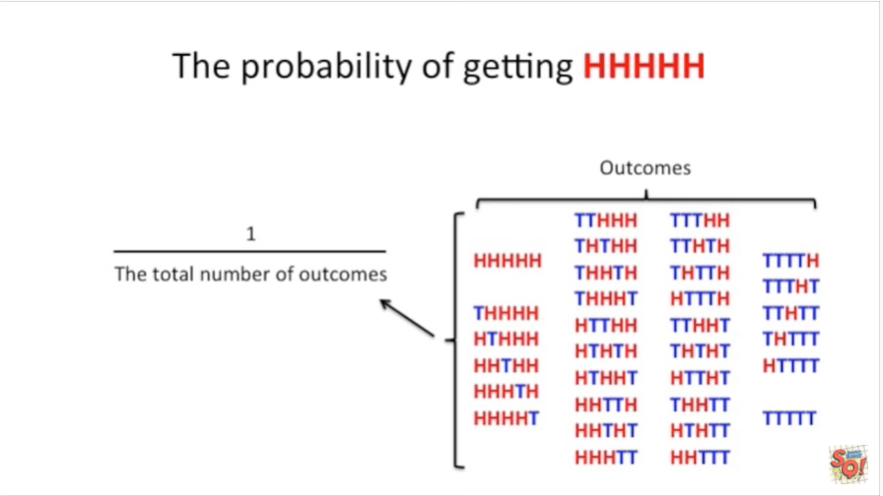

And since there are 32 different outcomes we put 32 in the denominator.

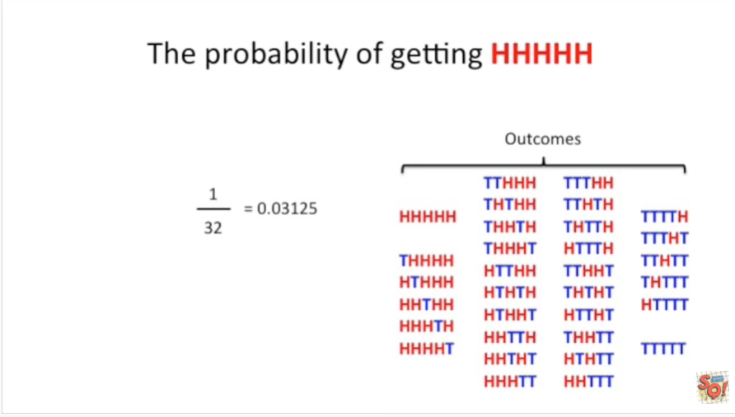

And the resulting value is a small number 0.03 something something something.

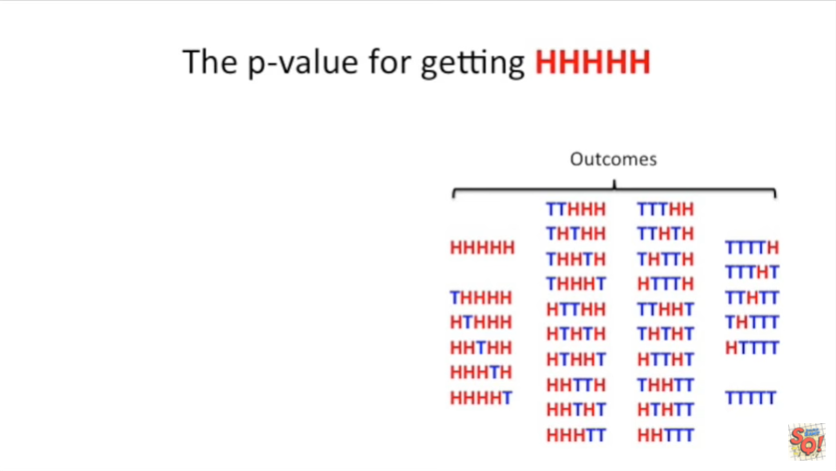

Now let's calculate the p-value for getting HHH HHH.

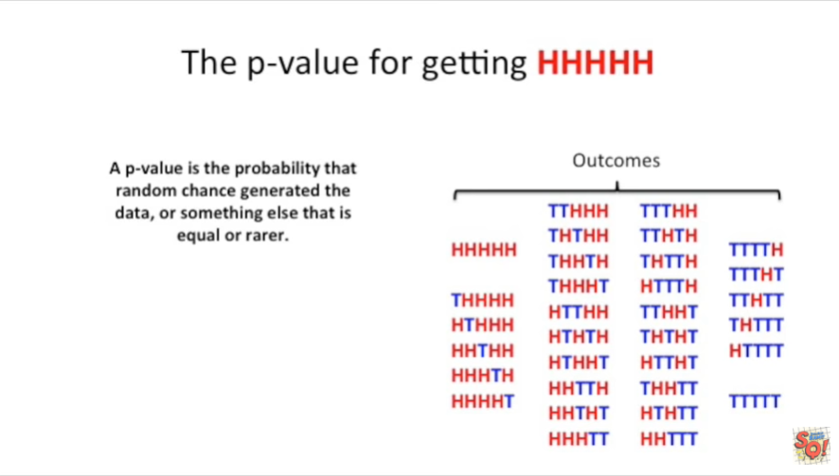

I hope that was five H's just to remind you a p-value is the probability that random chance that generated the data in this case five H's or something else that is equal or rarer.

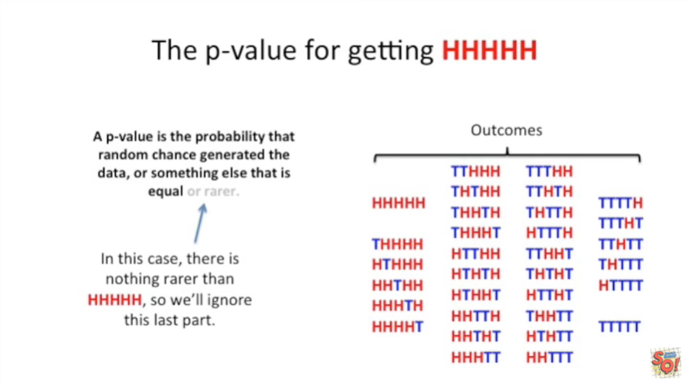

In this case there is nothing rarer than h HH HH so we'll ignore this last part just like before.

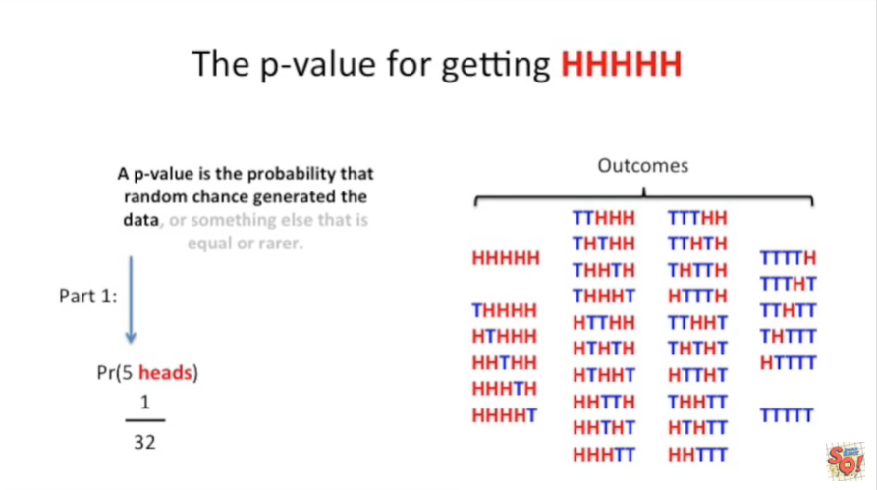

So part one of a p-value is the probability of 5 heads equals 1 over 32.

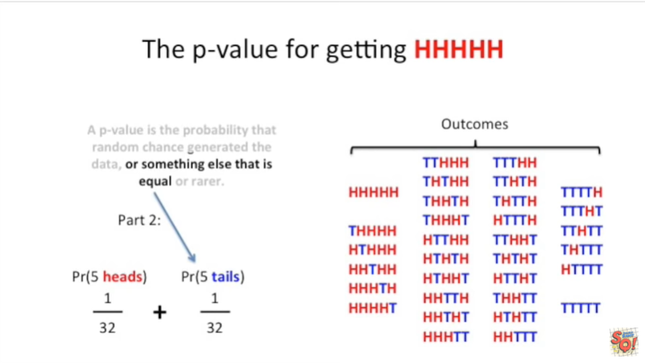

Part 2 of the p-value is the probability of 5 tails it's also equal to 1 over 32.

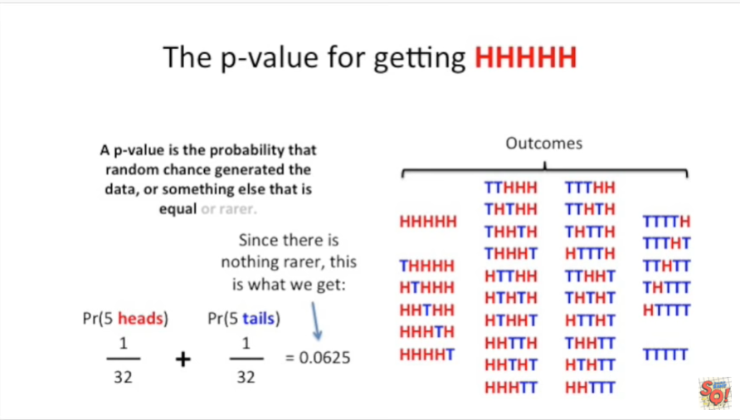

Since there is nothing rarer this is what we get 0.0625 for all you statisticians out there you'll notice that this p-value is not less than point zero five which is the traditional threshold for significance.

Even though the probability of getting five heads in a row is smaller than point zero five the p-value isn't.

So we wouldn't think it's all that unusual to get five heads in a row.

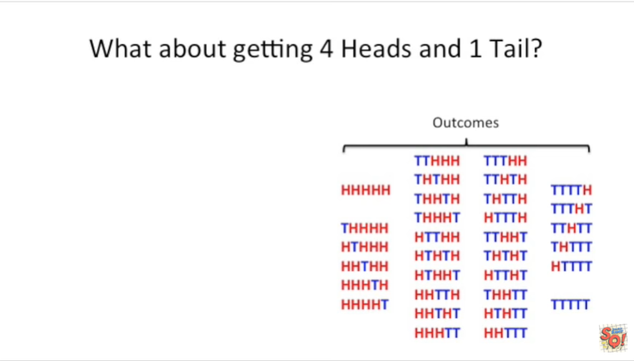

What about getting four heads and one tail ?

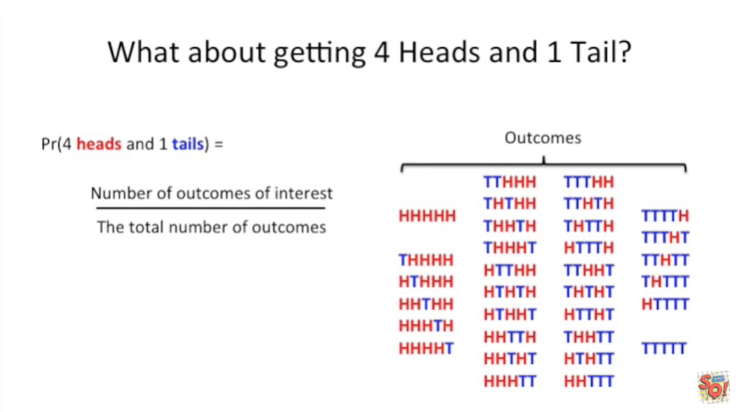

While calculating the probability is easy we already know how to do that.

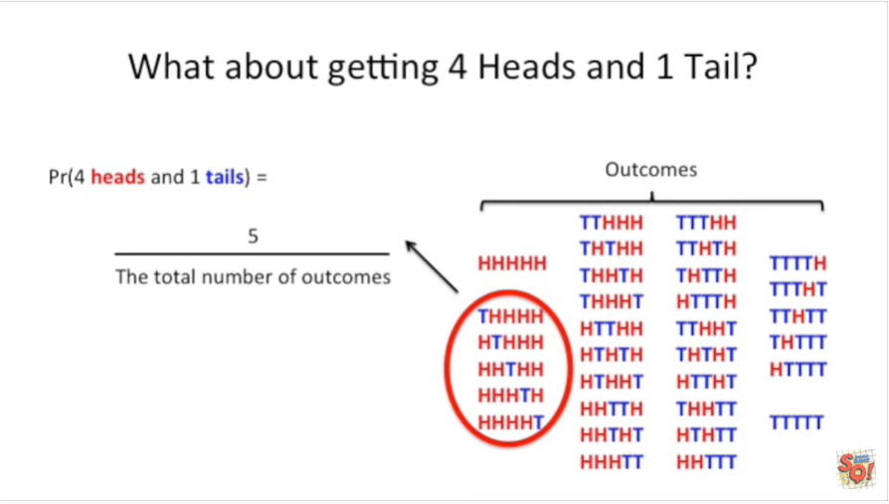

We just count up the number of outcomes of interest and put that number in this case five in the numerator and

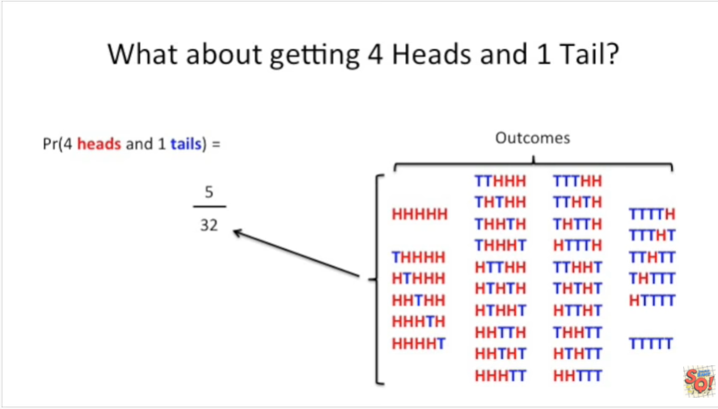

then count up the total number of outcomes and put that in the denominator the result is 0.15 something something something.

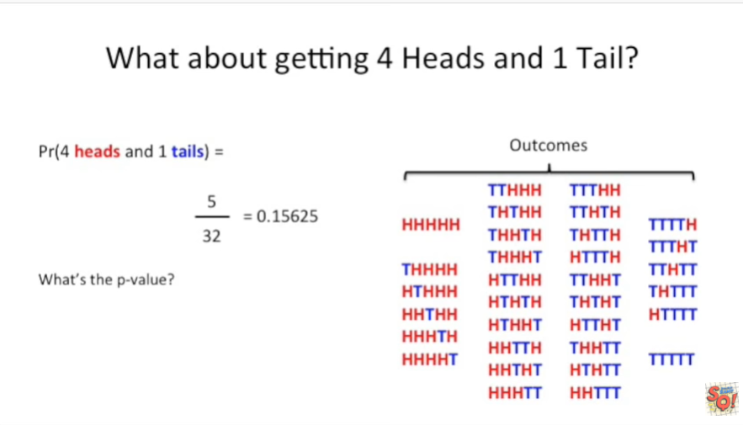

What's the p-value ?

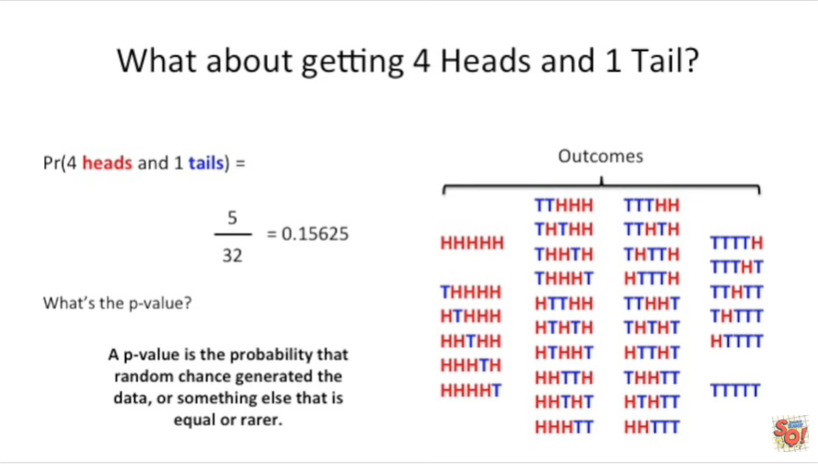

By now you've probably got this memorized a p-value is the probability that random chance generated the data and in this case the data is four heads and one tails or something else that is equal or rarer.

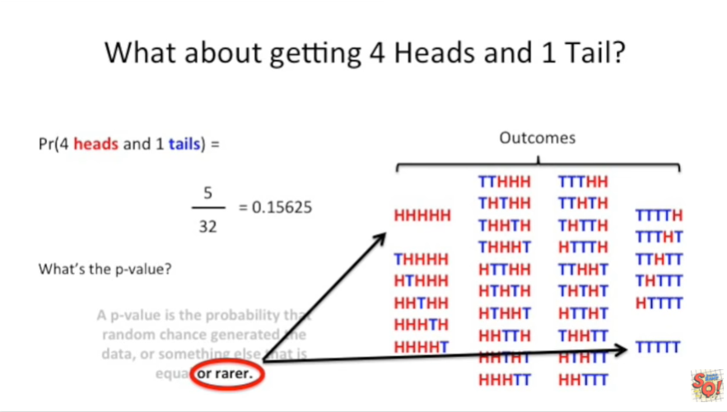

In this case there are two outcomes that are rarer than getting four heads and one tails.

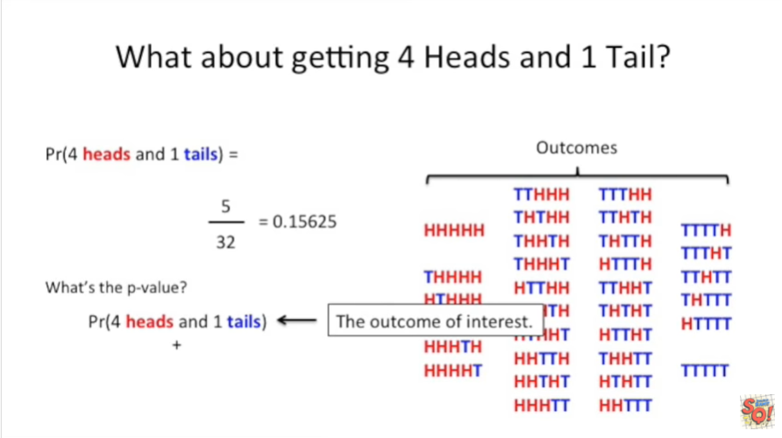

So we start with the probability of the outcome of interest

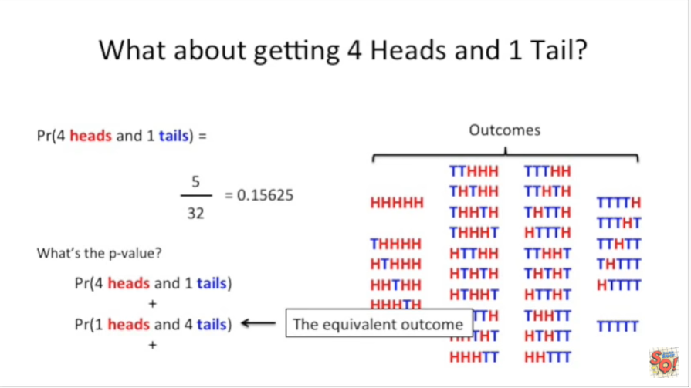

and we add to that the probability of an equivalent outcome which is one heads and four tails

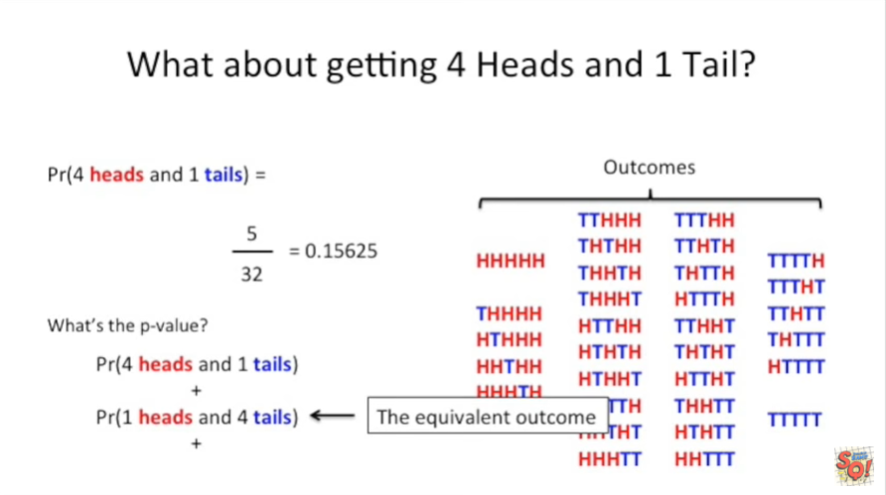

and then we add the probability of the two rare outcomes.

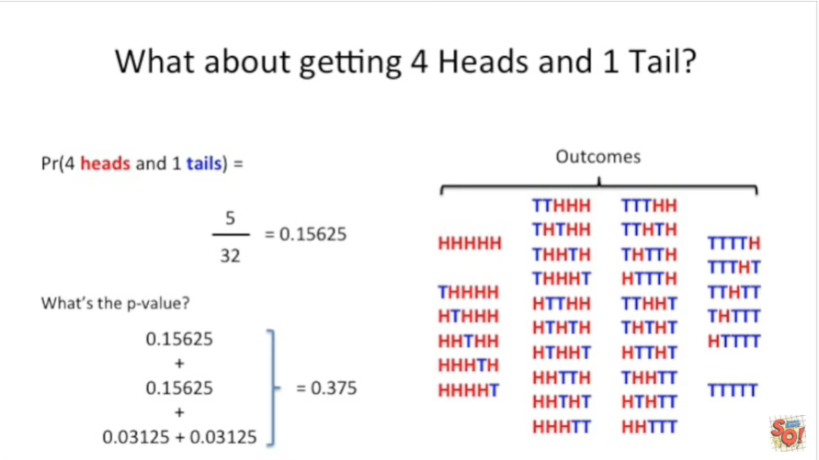

Plugging in the numbers we get a p-value equal to 0.375.

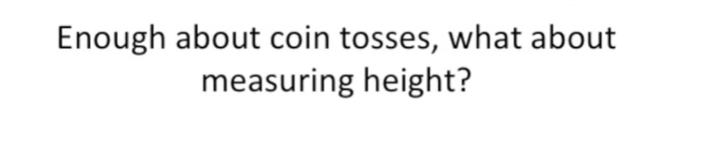

Okay enough about coin tosses what about measuring height ?

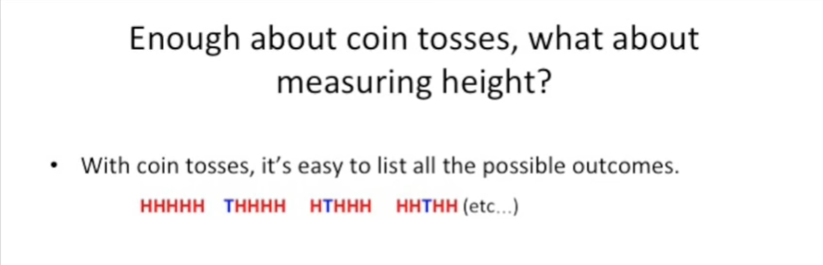

With coin tosses it's easy to list all the possible outcomes.

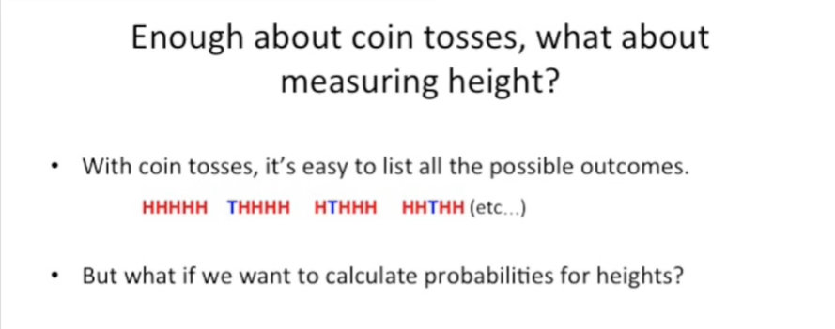

But what if we want to calculate probabilities for Heights.

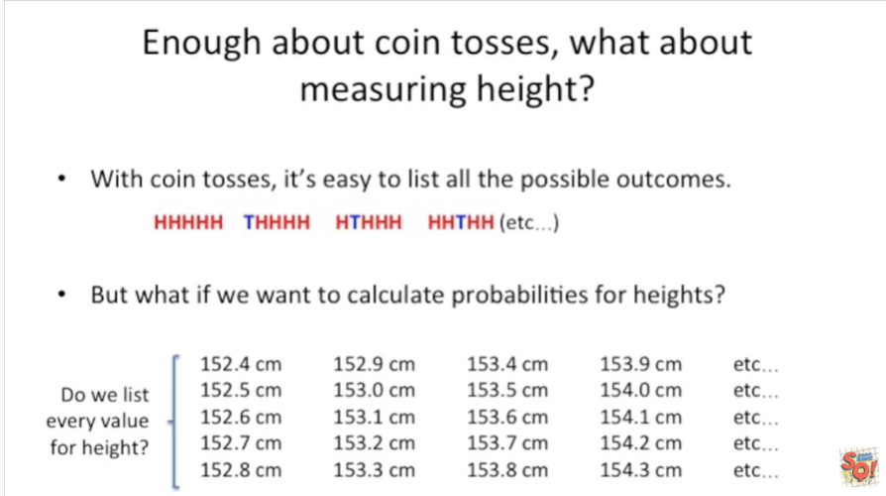

Do we list every value for height ?

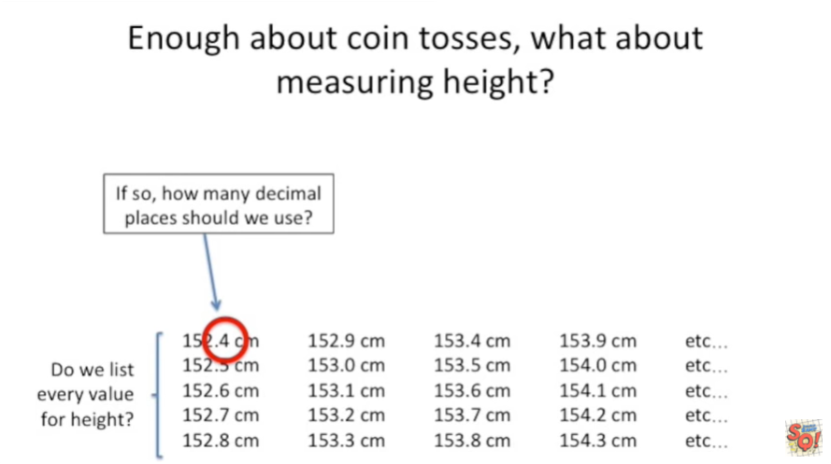

If so how many decimal places should we use ?

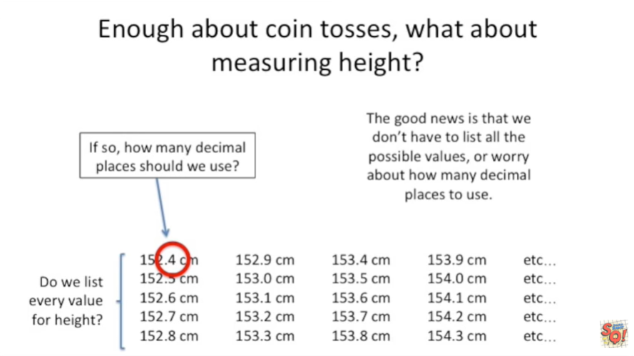

The good news is that we don't have to list all the possible values or worry about how many decimal places to use.

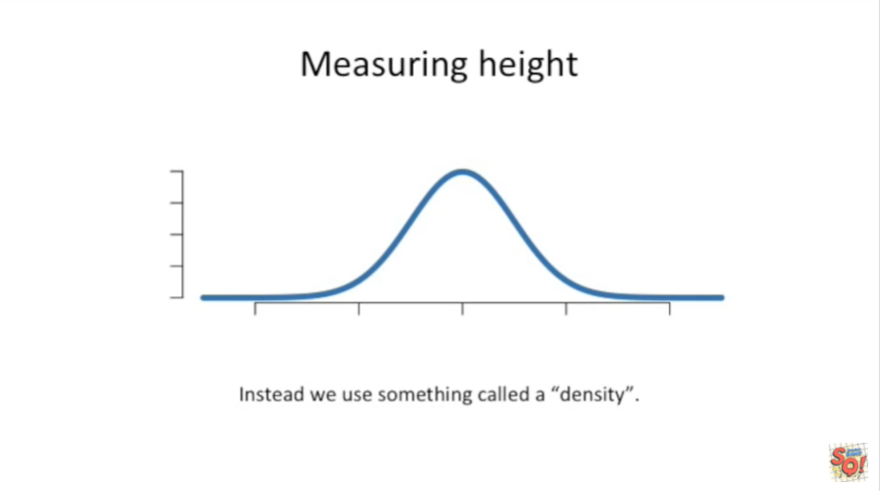

Instead we use something called a density.

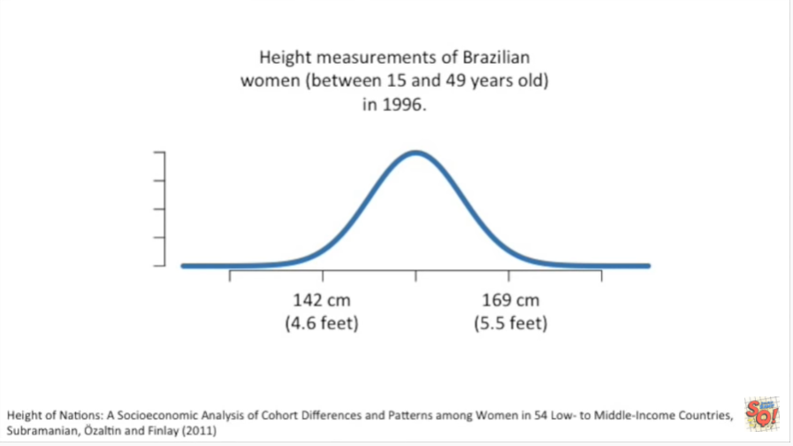

For these examples I've got height measurements of Brazilian women between the ages of 15 and 49.

And these people were measured in 1996.

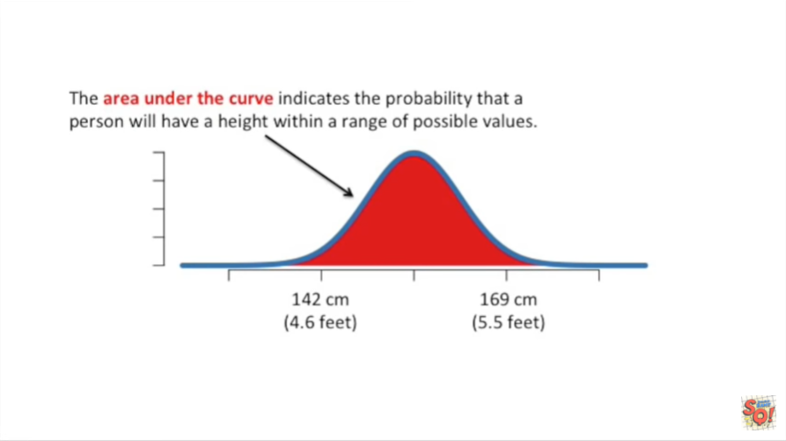

The area under the curve indicates the probability that a person will have a height within a range of possible values.

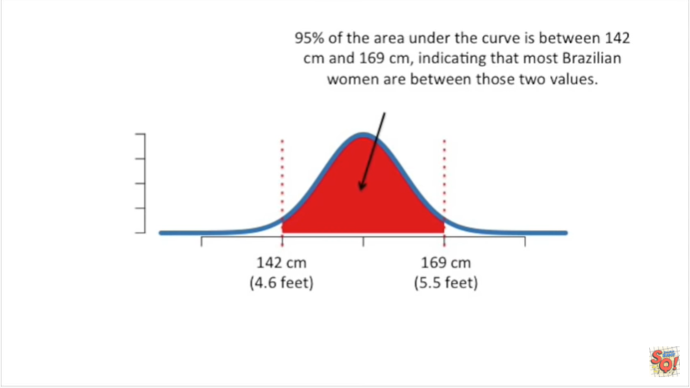

95% of the area under the curve is between 142 centimeters and 169 centimeters indicating that most Brazilian women are between these two values.

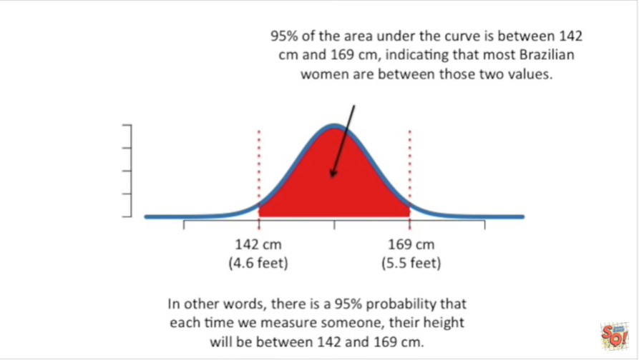

In other words there is a 95% probability that each time you measure someone their height will be between 142 and 169 centimeters.

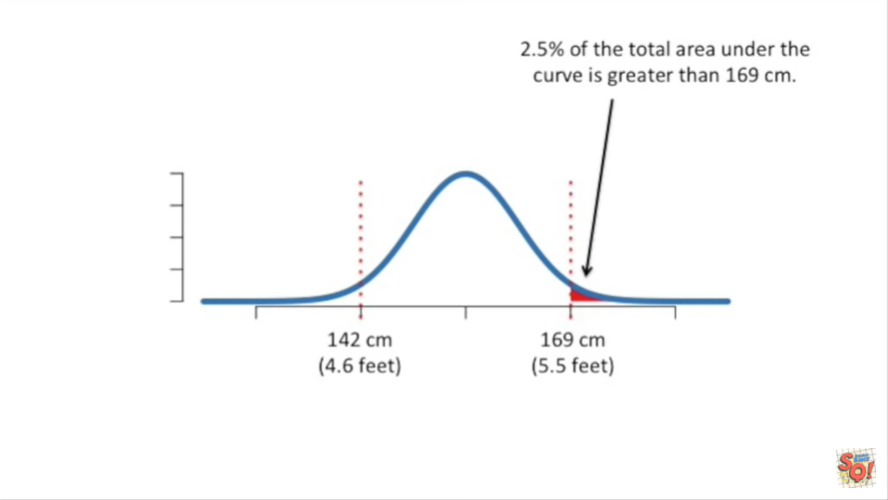

2.5 percent of the total area under the curve is greater than 169 centimeters.

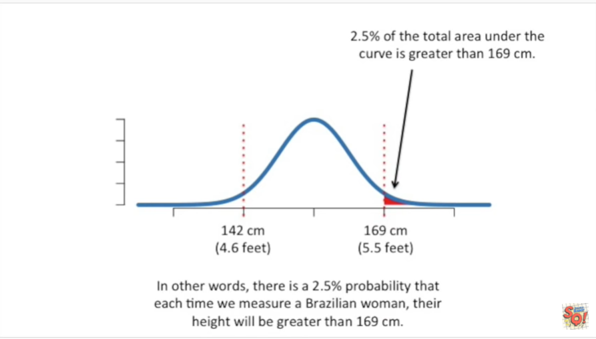

In other words there's a 2.5 percent probability that each time we measure a Brazilian woman their height will be greater than 169 centimeters.

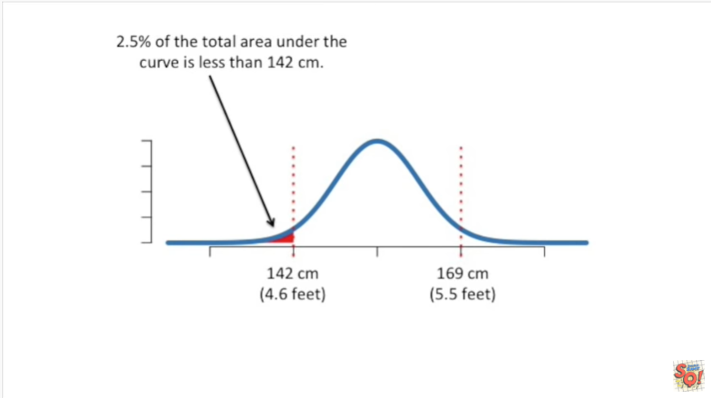

Also 2.5 percent of the total area under the curve is less than 142 centimeters.

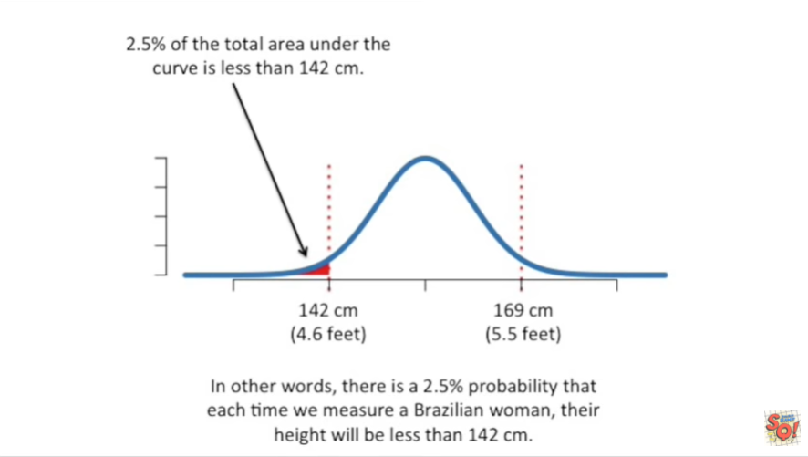

In other words there's a 2.5 percent probability that each time you measure a Brazilian woman their height will be less than 142 centimeters.

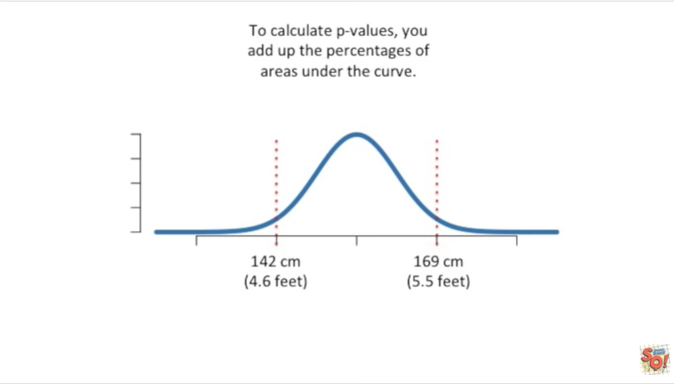

To calculate p-values you add up the percentages of areas under the curve.

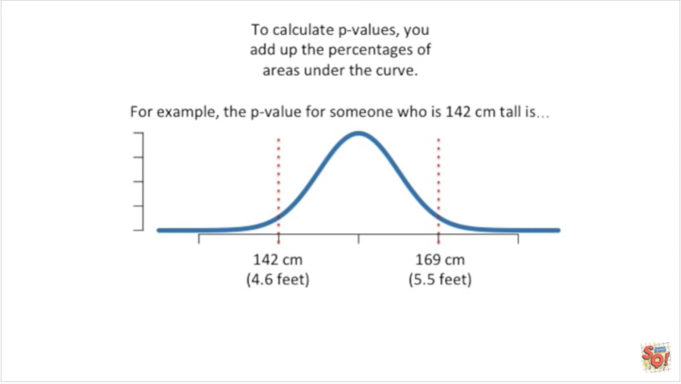

For example the p-value for someone who is 142 centimeters tall is

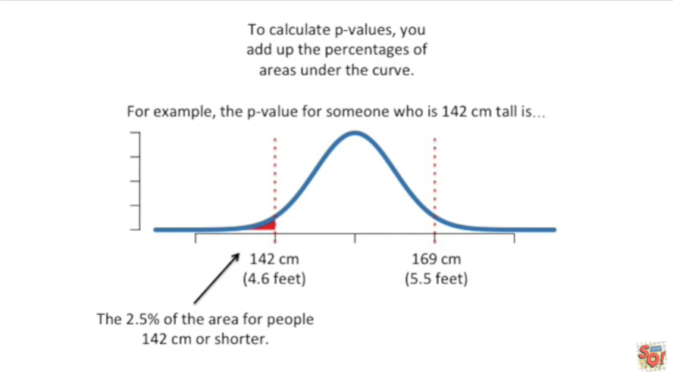

the 2.5 percent of the area for people that are 142 centimeters or shorter.

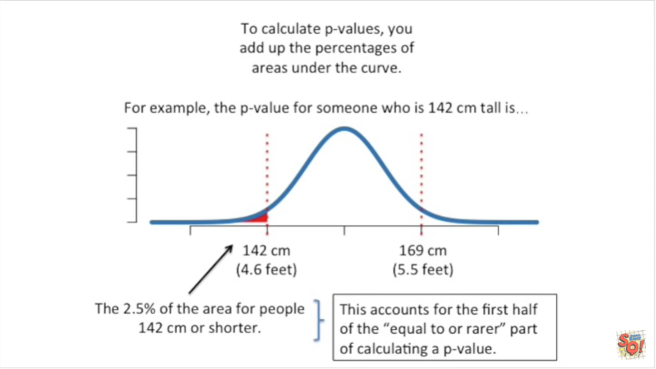

This accounts for the first half of the equal or rarer part of calculating a p-value

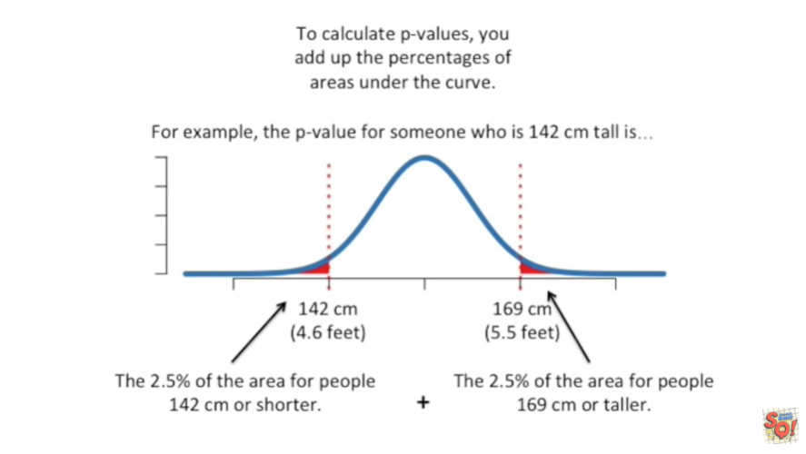

and we add to that the 2.5% of the area for people that are 169 centimeters or taller

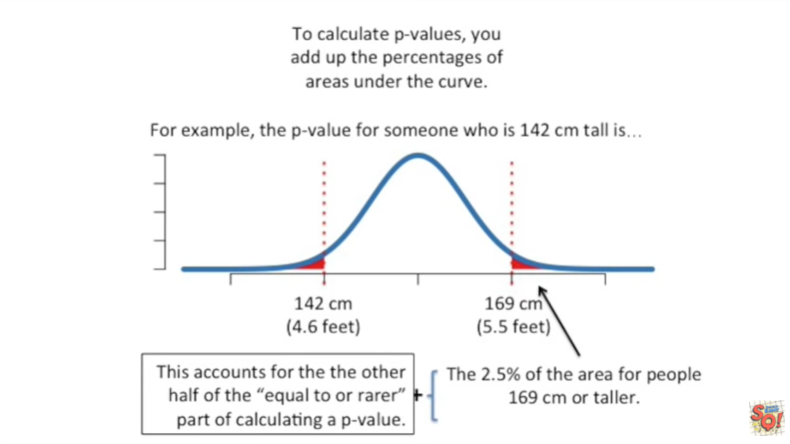

this accounts for the other half of the equal or rarer part of calculating a p-value.

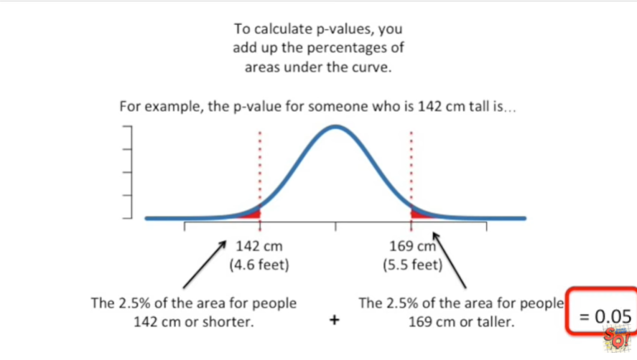

Thus the p-value is 0.05 or 5%.



BAM

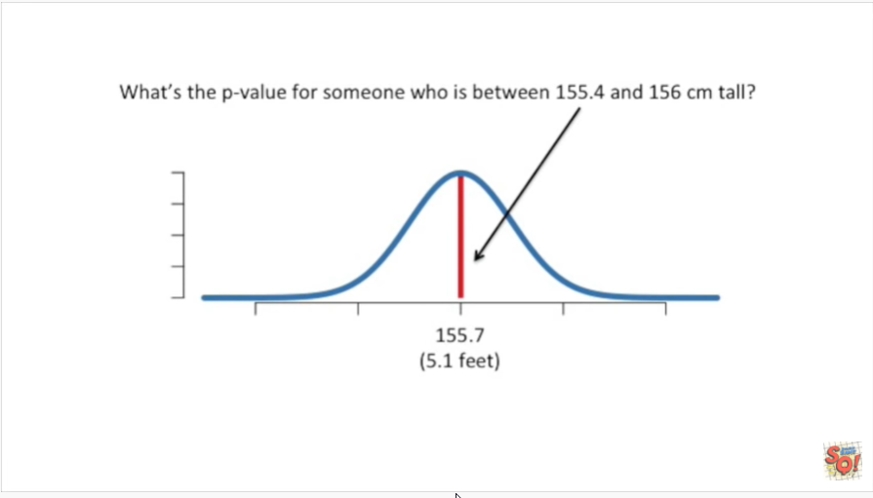

Alright one last example what's the p-value for someone who's between one hundred and fifty five point four centimeters tall and 156 centimeters tall.

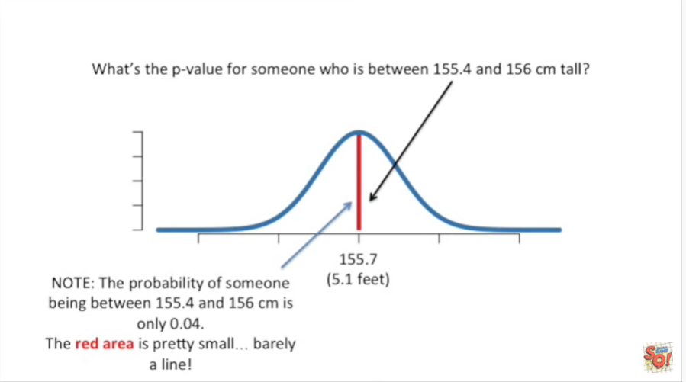

Note : the probability of someone being between one hundred and fifty five point four in one hundred and fifty six centimeters is only 0.04 or four percent.

The red area under the curve is pretty small it's barely aligned.

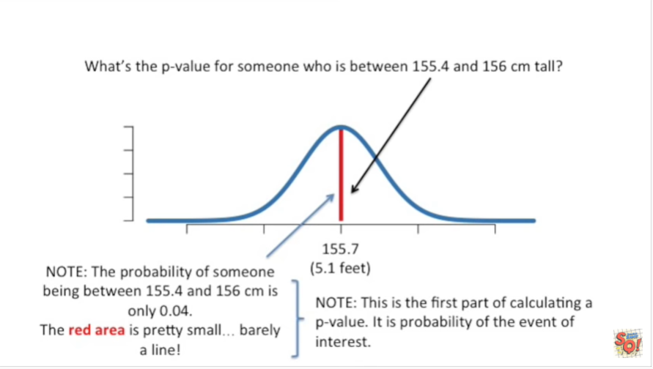

Note : this is the first part of calculating a p-value it is the probability of the event of interest.

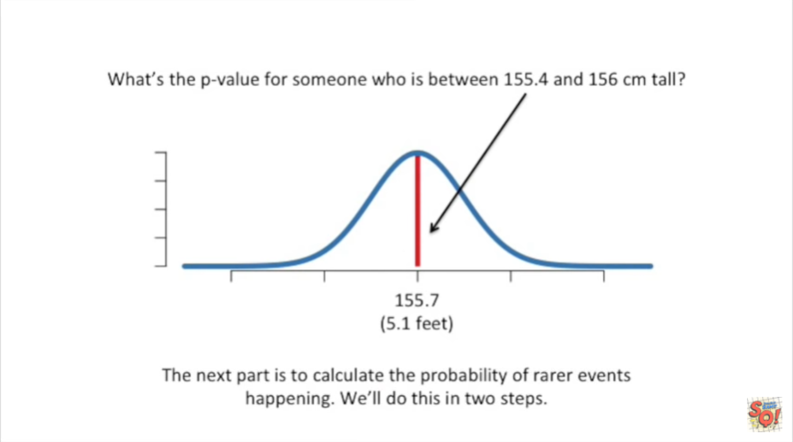

The next part is to calculate the probability of rarer events happening we'll do this in two steps.

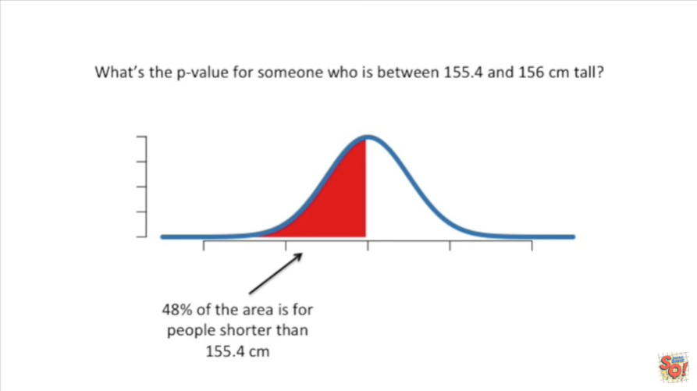

First we see that 48% of the area is for people shorter than 150 5.4 centimeters.

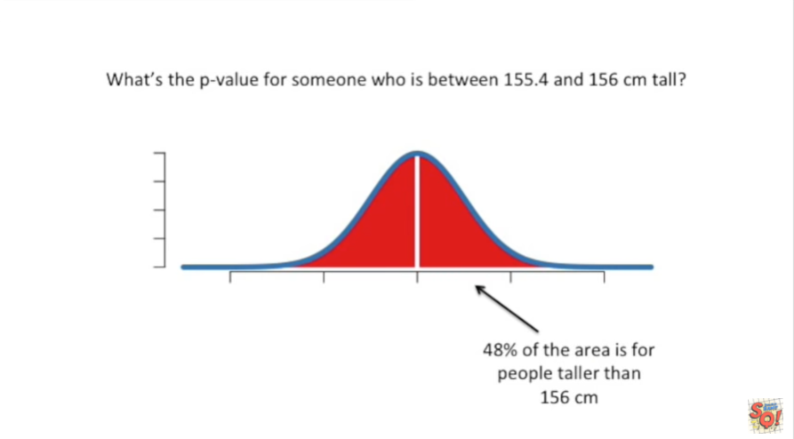

Second we see that 48 percent of the area is for people taller than 156 centimeters.

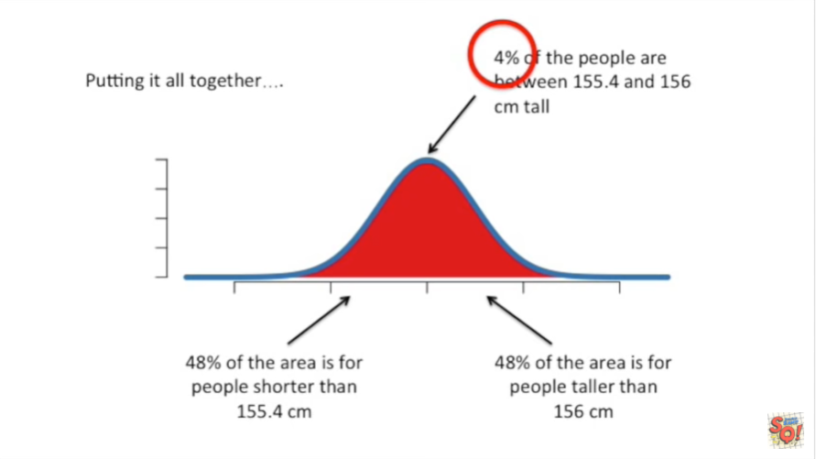

Now we can put these three things together we've got four percent of the people between 155 point four and 156 centimeters tall,

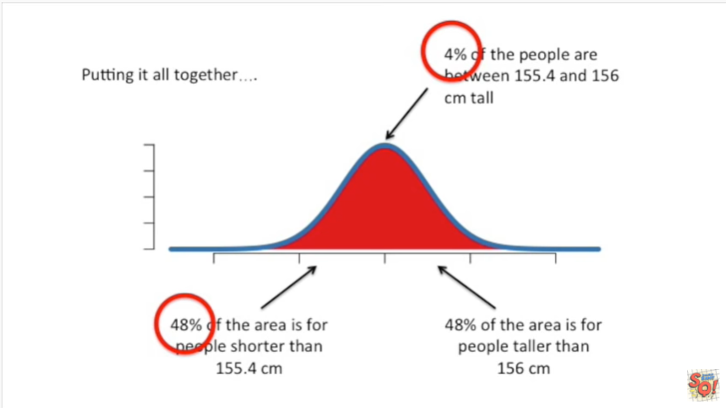

48 percent of the areas for people shorter than that

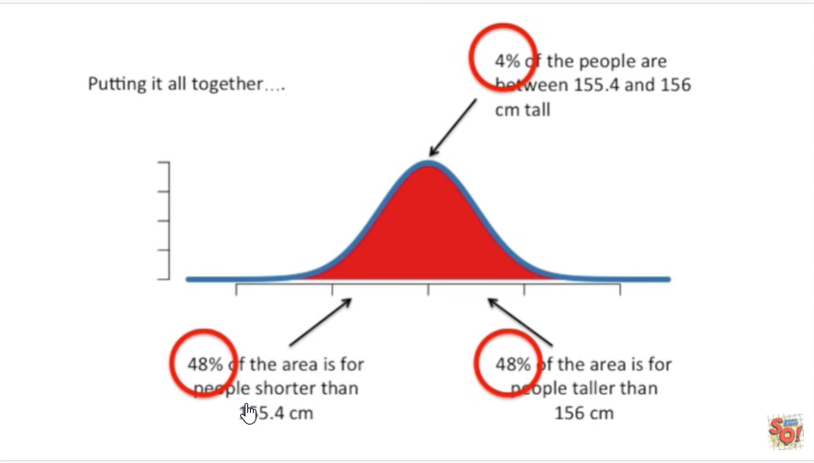

and 48 percent of the areas for people taller than

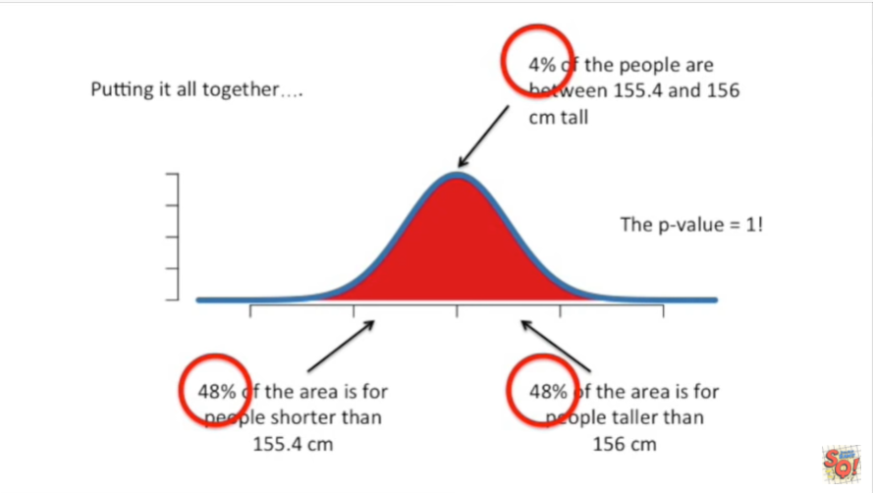

that that makes the p-value equal to one.

That means there's nothing all that special about measuring someone who has the average height even though that event in particular is fairly rare.

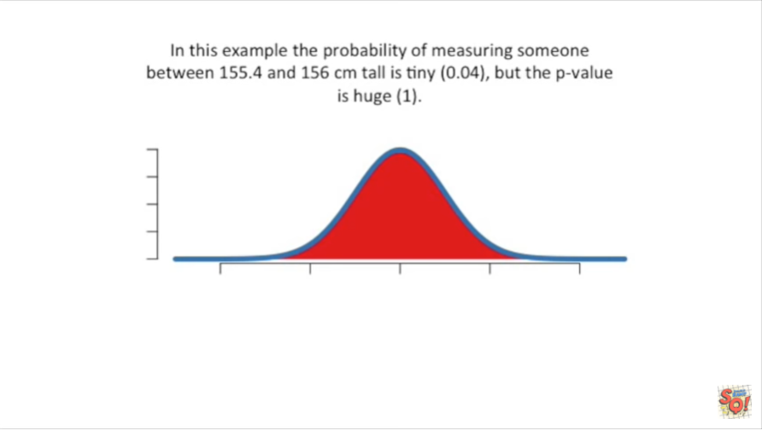

In this example the probability of measuring someone between 155 point four and 156 centimeters tall is tiny 0.04 but the p-value is huge one like I just said that means that there's nothing special about measuring someone who has the average height even though that particular event is relatively rare.